**Jenkins day-3**

**Jenkins User Management**

* What is the Role Strategy in Jenkins?
  + How to install the Role-based strategy plugin in Jenkins?
  + And, how to enable the Role-based Strategy on Jenkins?
* How to Create a User in Jenkins?
  + How to manage user roles in Jenkins?
  + And, how to assign roles to a user in Jenkins?
* What is a Project-based Matrix Authorization strategy in Jenkins?
  + How to assign job-specific permissions in Jenkins?

**What is the Role Strategy in Jenkins?**

The role-based strategy helps in defining what different access types can be assigned to individual users. As we discussed, not all the users can be provided administrative privileges, So [**Jenkins**](https://www.toolsqa.com/jenkins/what-is-jenkins/) provides the capability to provide different roles to individual users. This capability is achieved using the [**"Role-based strategy plugin".**](https://plugins.jenkins.io/role-strategy/)

The Role-based strategy plugin is a special kind of plugin in Jenkins that is based on the role-based mechanism and allows us to manage users' permission. A few of the major features provided by this plugin are:

* Global roles such as admin, anonymous, job creator that allows setting permission like job, view, agent, run and SCM, etc.
* Project roles that allow us to access particular projects with jobs and run permissions.
* Agent roles that are used to set node related permissions.
* Roles can be assigned to users and user groups with the help of this plugin.

So, let's understand how we can install this plugin in Jenkins and start using its capabilities for managing the user roles?

1.Launch instance

Security group inbound rules for Jenkins Instance

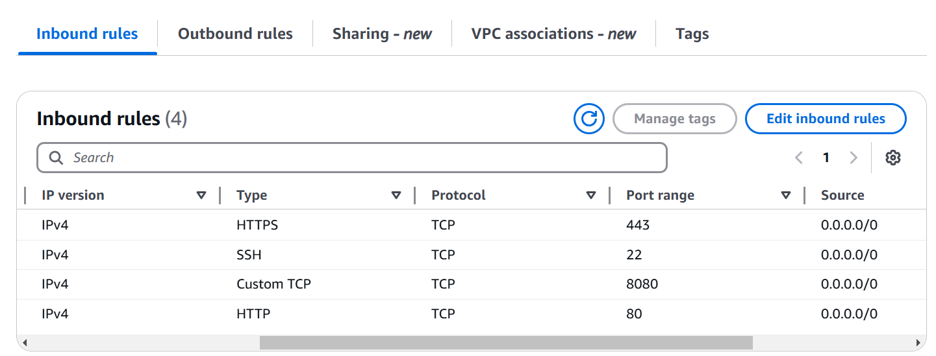

And iam role for Jenkins instance

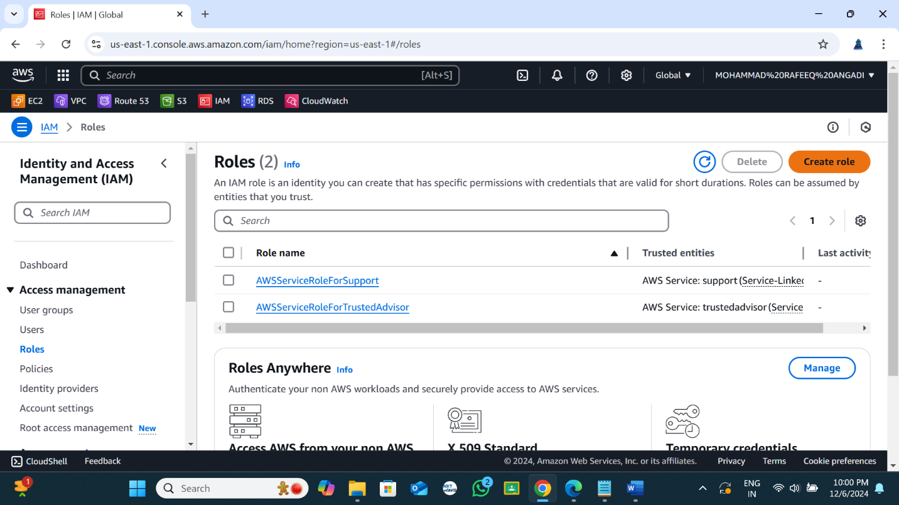

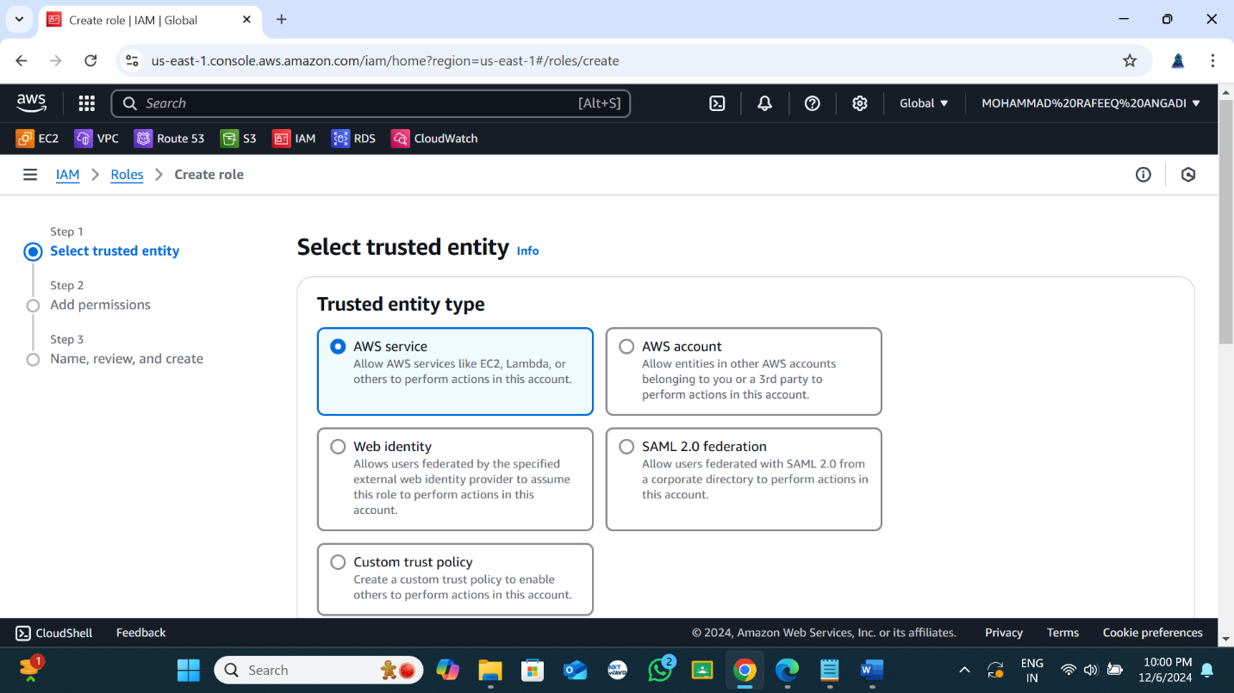

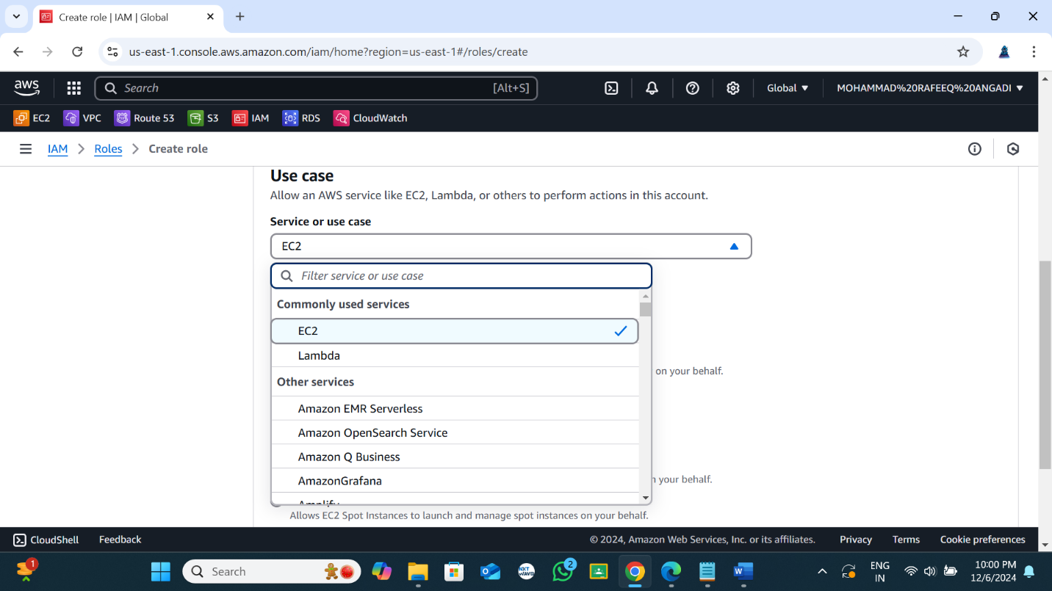

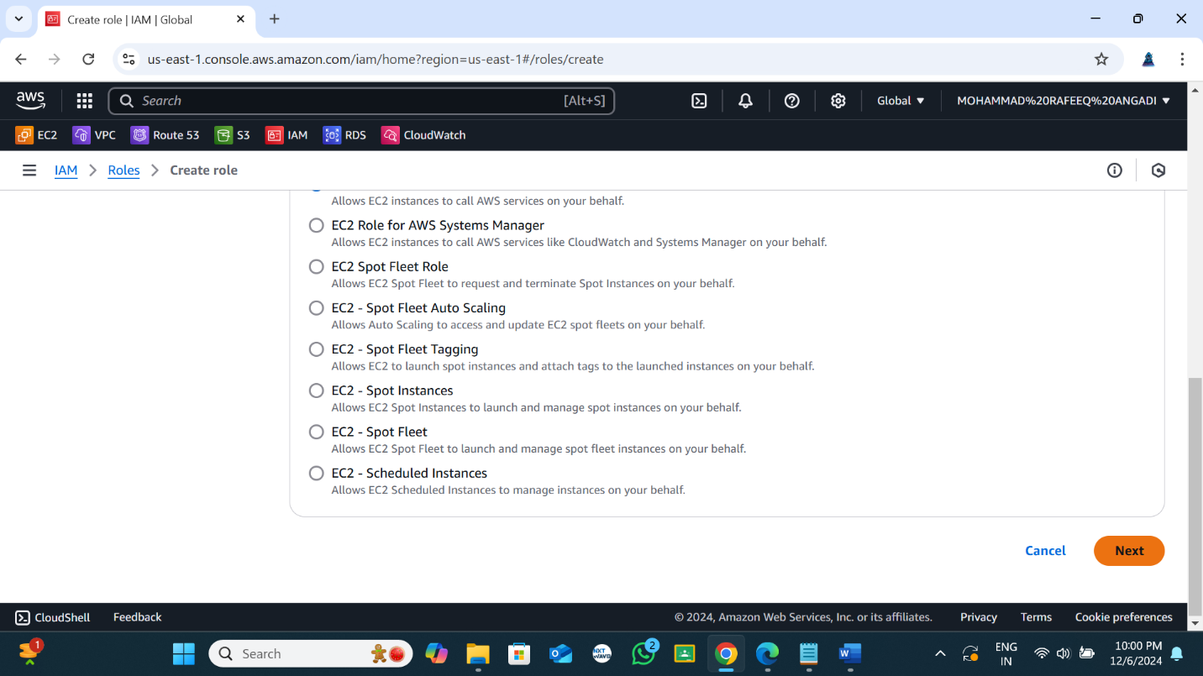 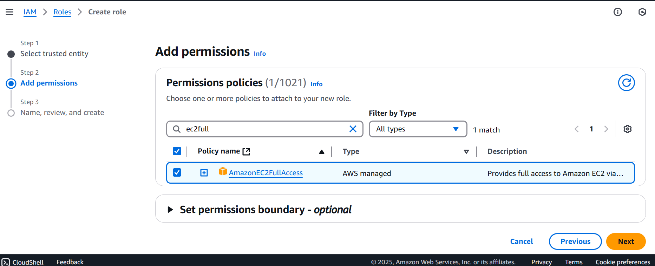

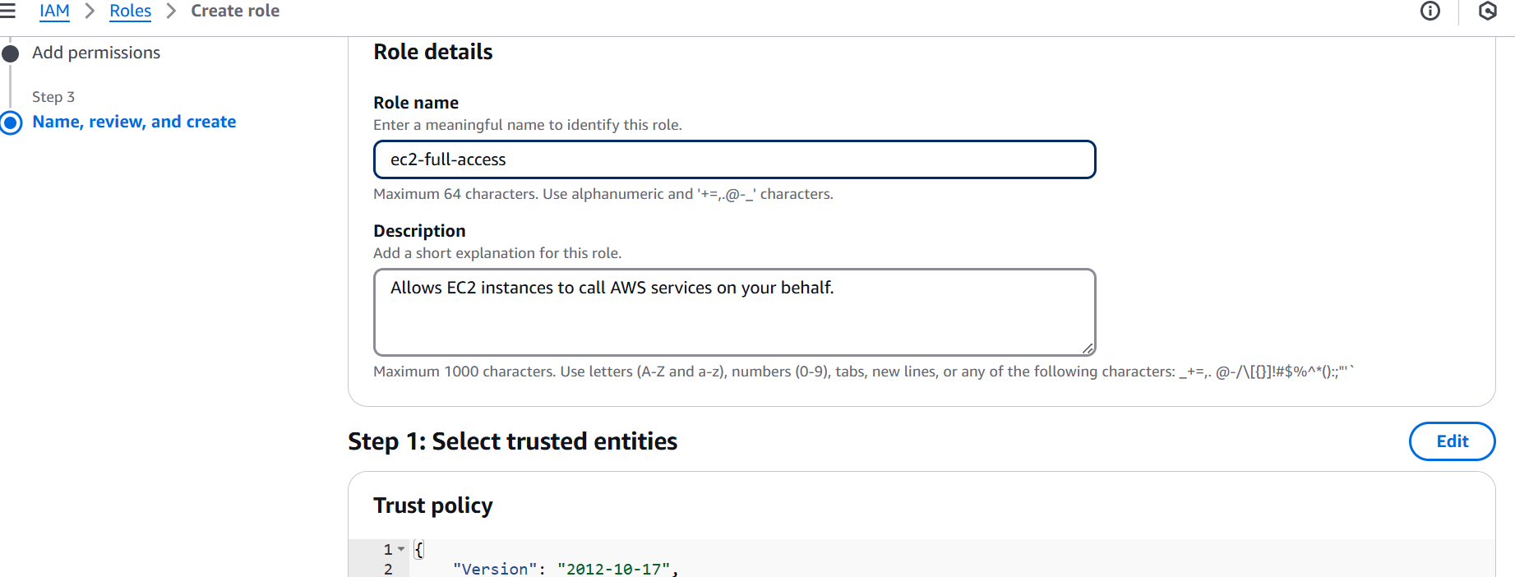

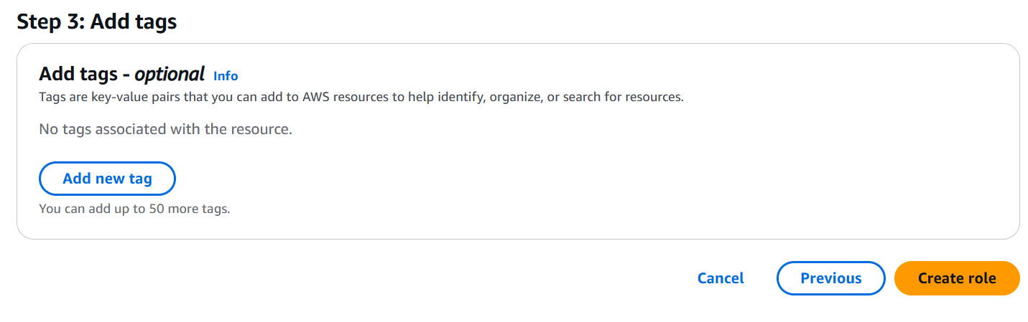

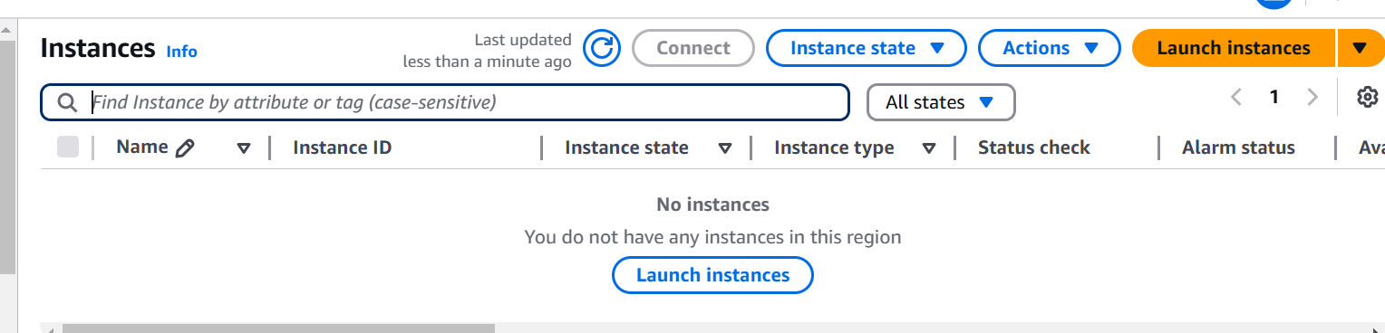

Security group port numbers

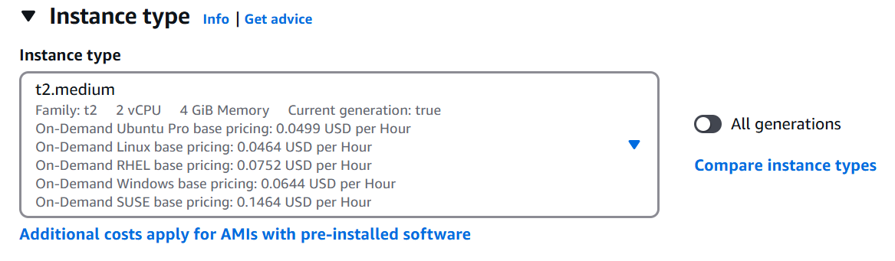

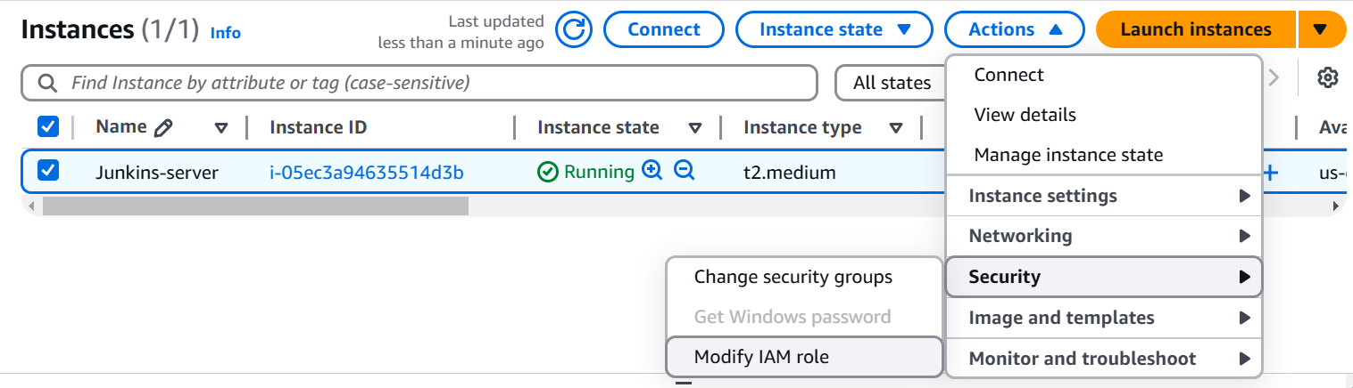

**4**

**2**

**3**

**1**

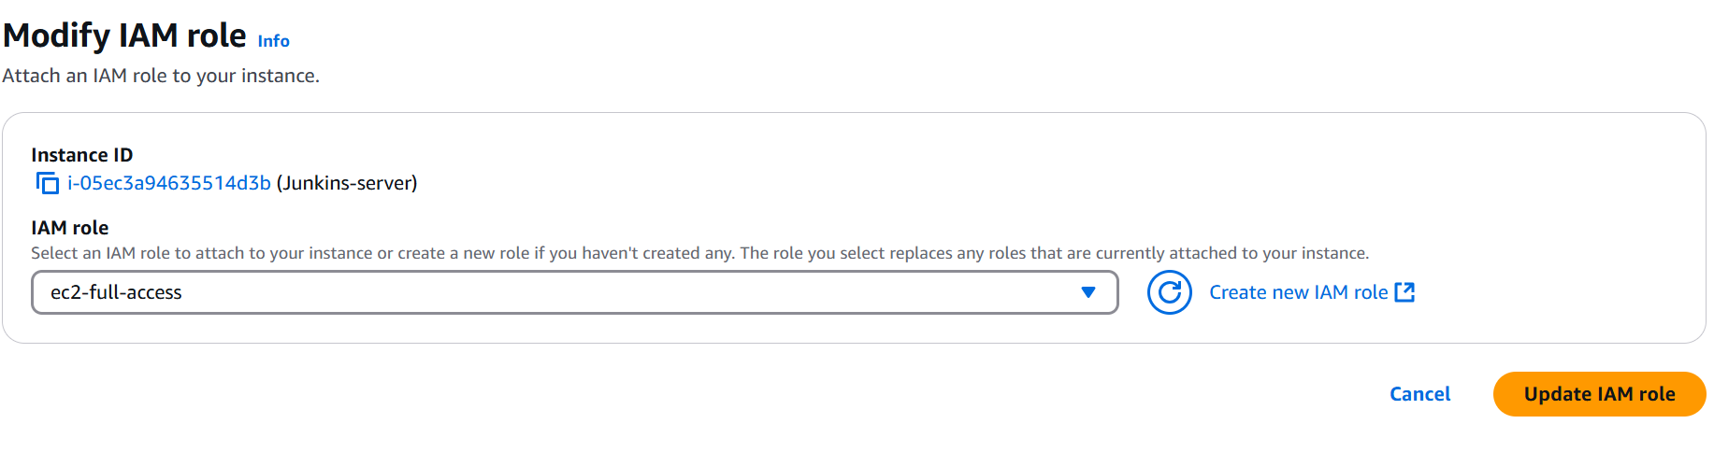

Connect the instance

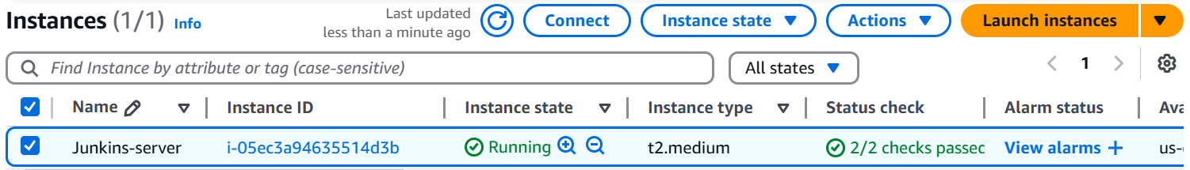

And run the below commands

sudo su –

#-------java dependency for jenkins------------

sudo yum install java-17-amazon-corretto.x86_64

#------------jenkins install-------------open this link and copy the Jenkins install command ctrl + click to open

[Terraform-main/project-terraform-devops-tools-install/install.sh at main · CloudTechDevOps/Terraform-main](https://github.com/CloudTechDevOps/Terraform-main/blob/main/project-terraform-devops-tools-install/install.sh)

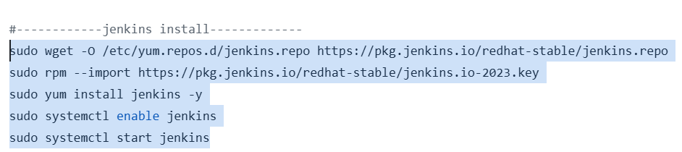

# ------------------install terraform ------------------

sudo yum install -y yum-utils

sudo yum-config-manager --add-repo https://rpm.releases.hashicorp.com/AmazonLinux/hashicorp.repo

sudo yum -y install terraform

#------- install git -----------

yum install git -y

#---------Connect Jenkins server ----------------

#search your server ip address in browser with 8080 port number

ex: 34.203.12.149:8080 #your server security group is allowed 8080 ports

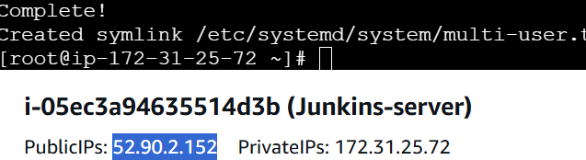

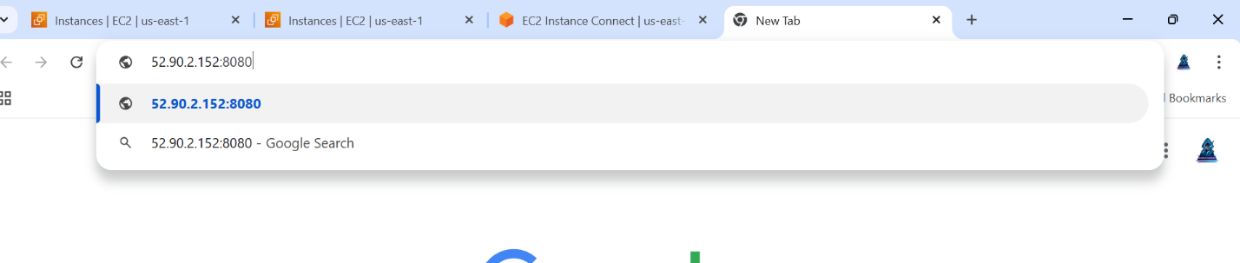

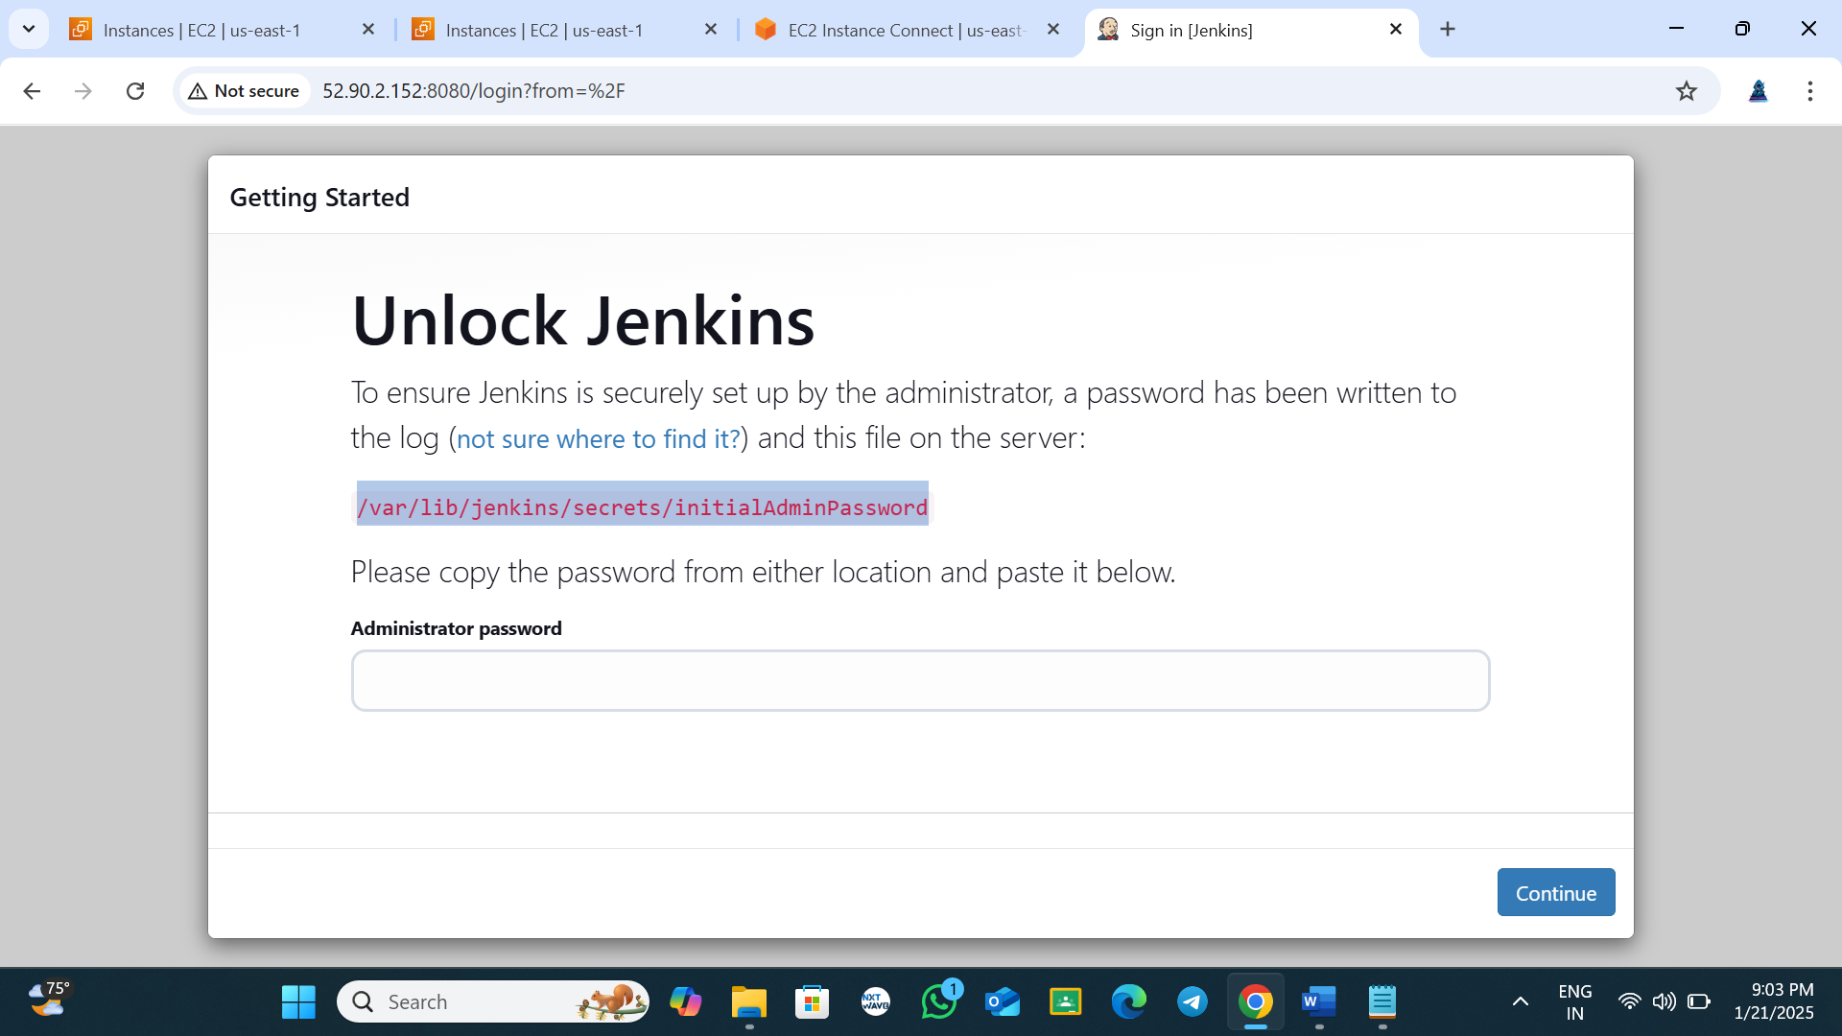

**Copy the path**

#copy the path in the server and run in server like below command

cat /var/lib/jenkins/secrets/initialAdminPassword #copy the password and past in Jenkins browser



Copy the password and past in Jenkins server like below

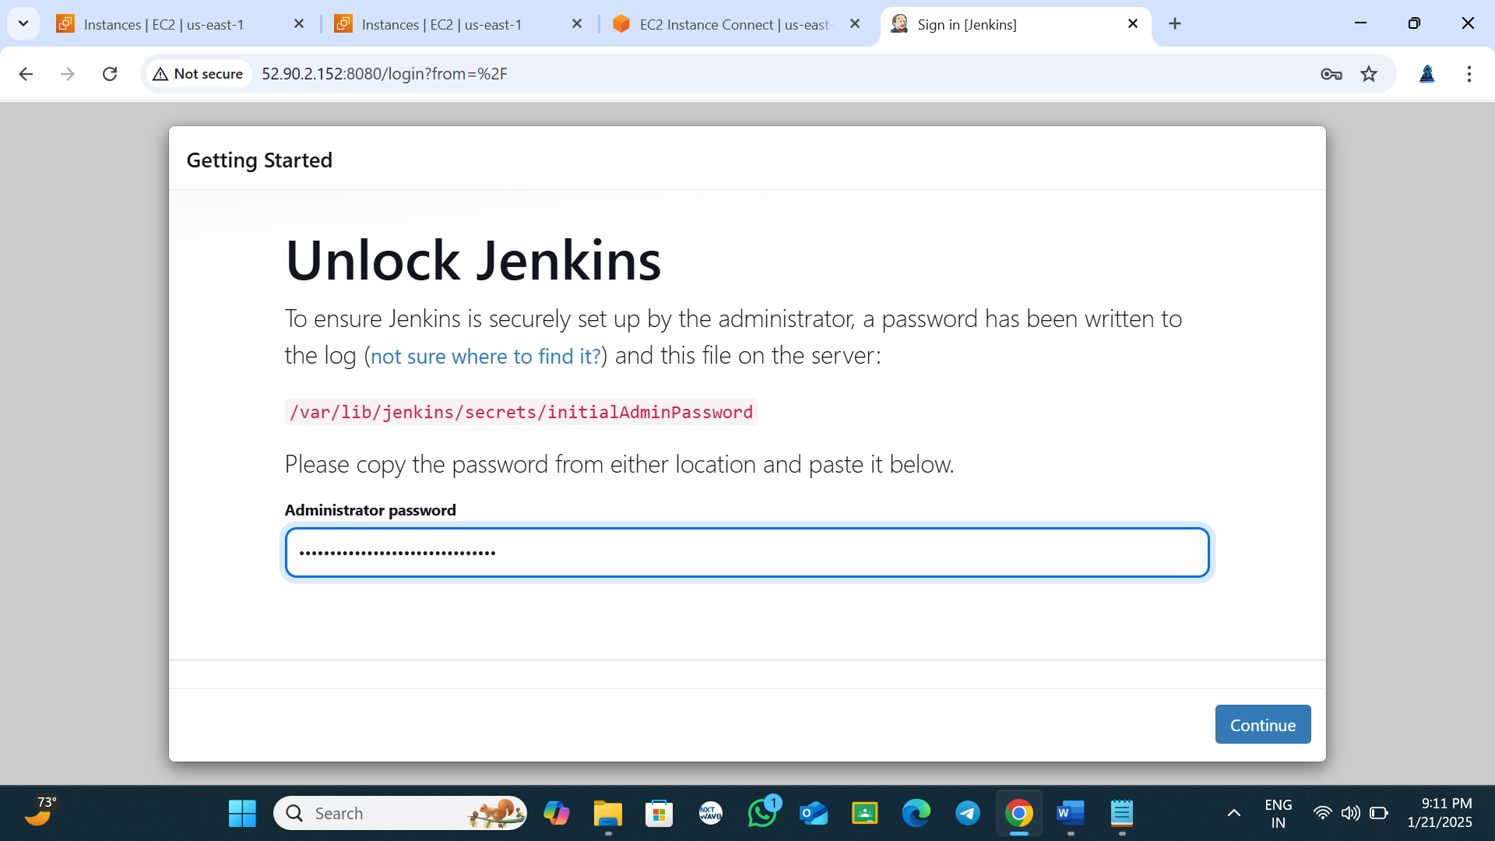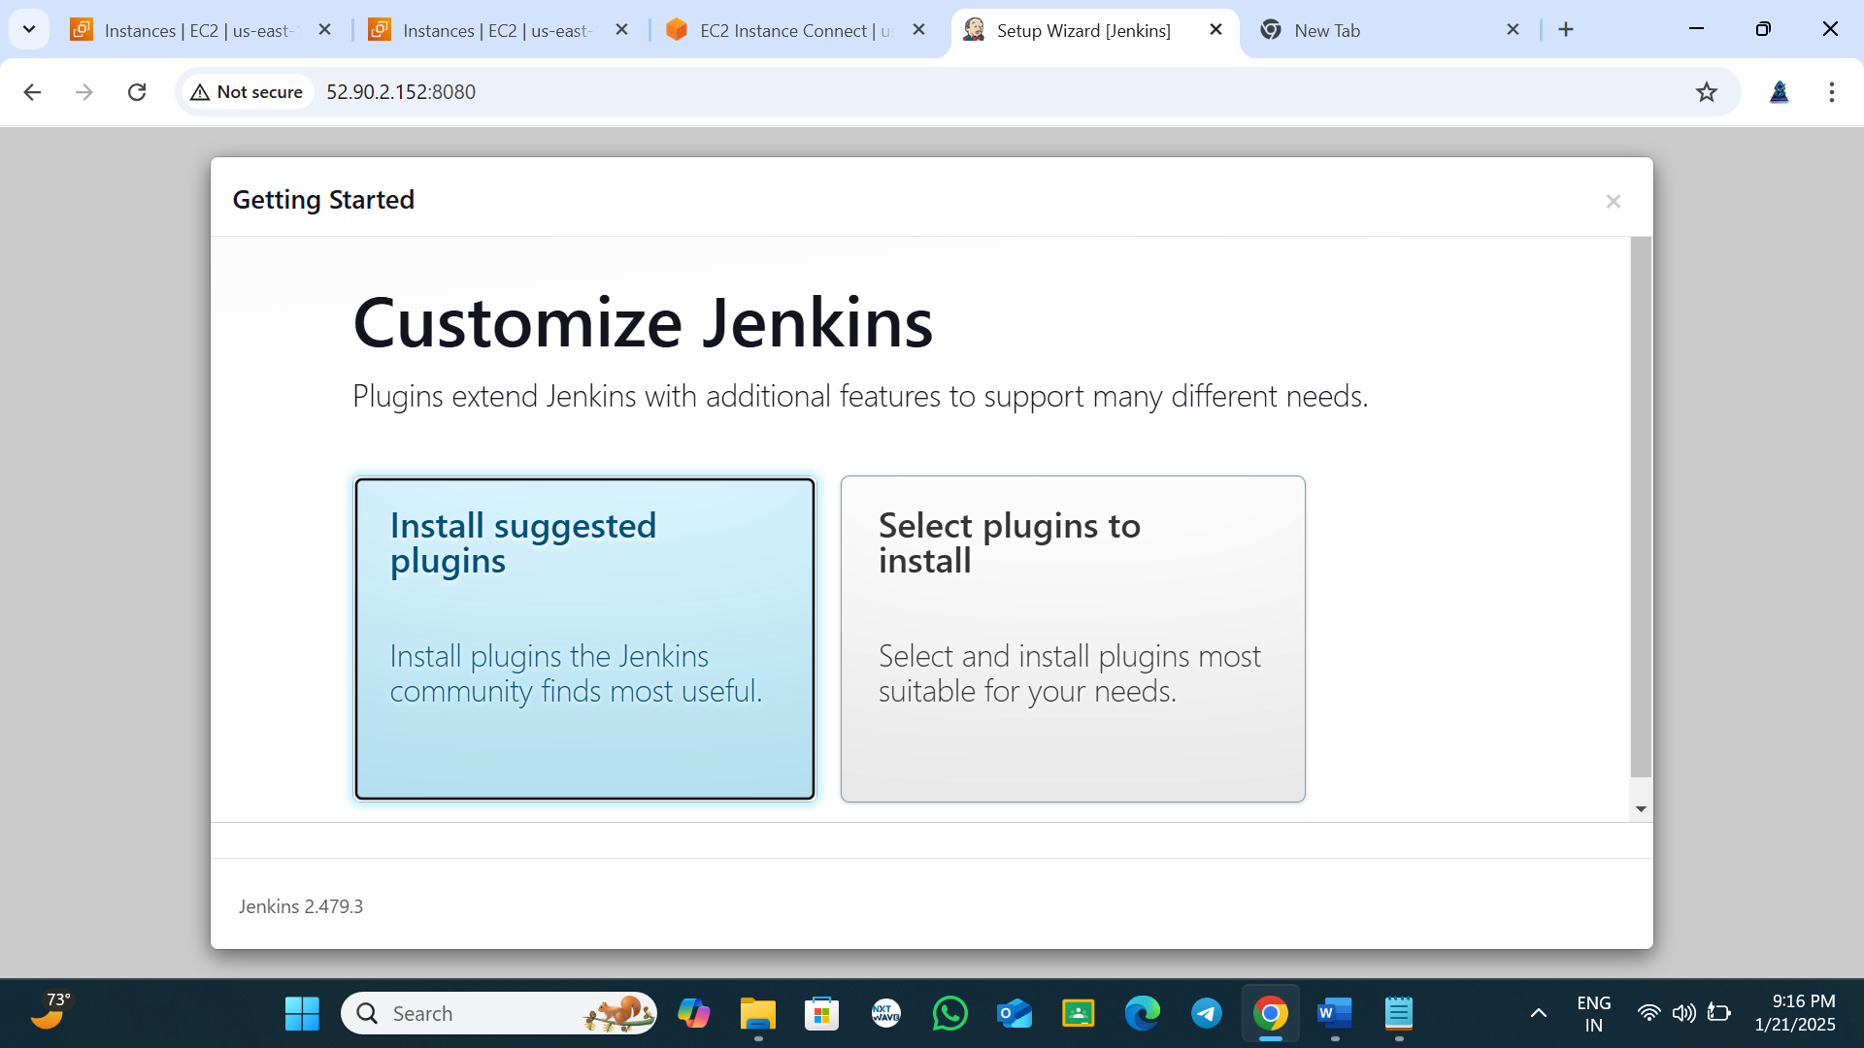

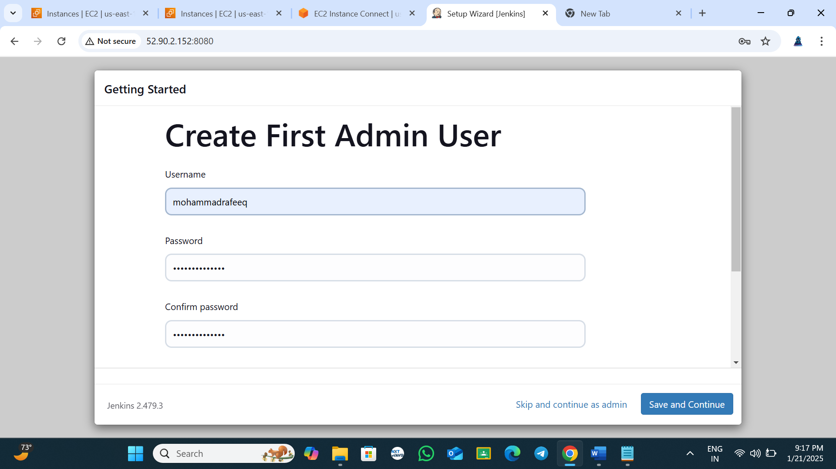

Fill up the details

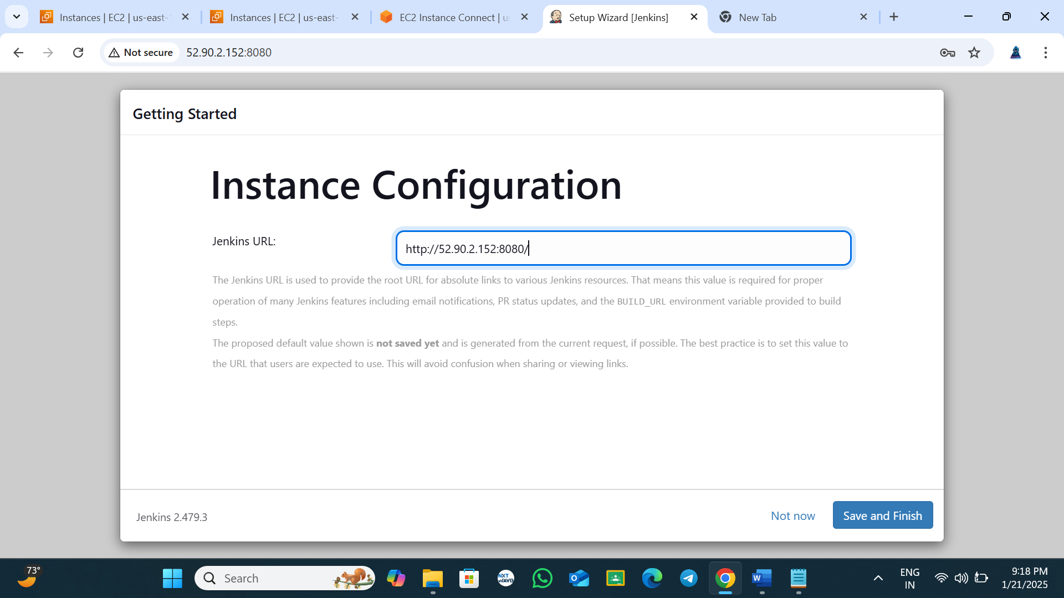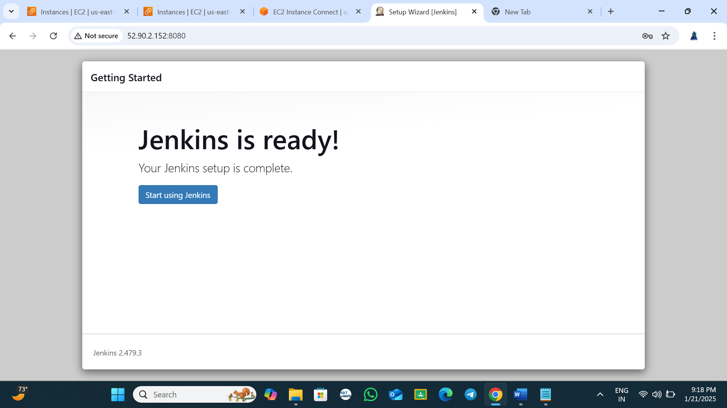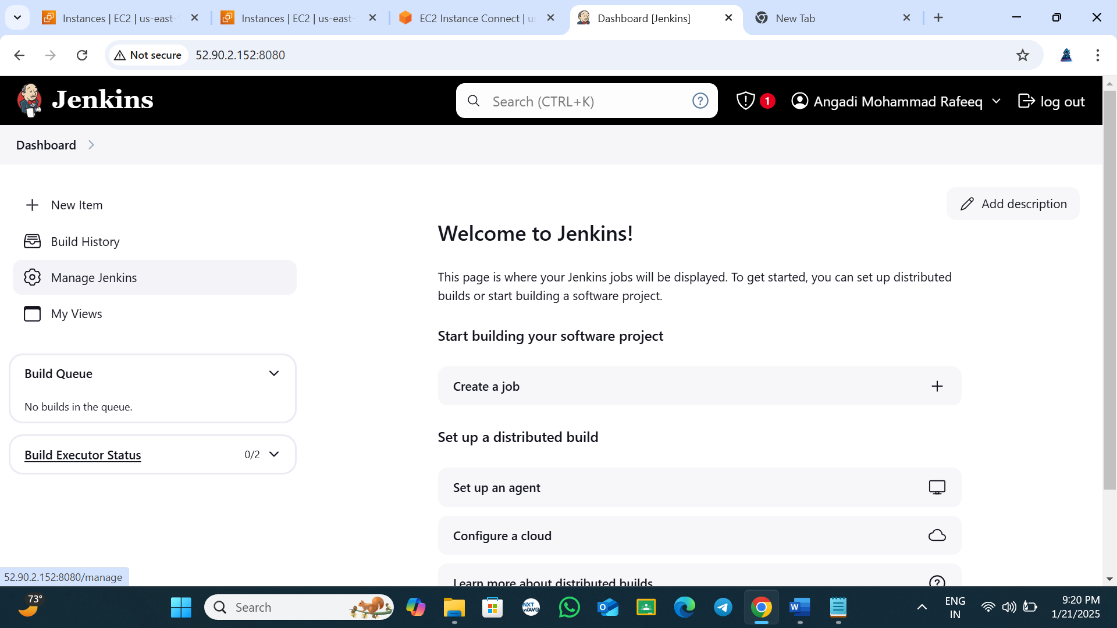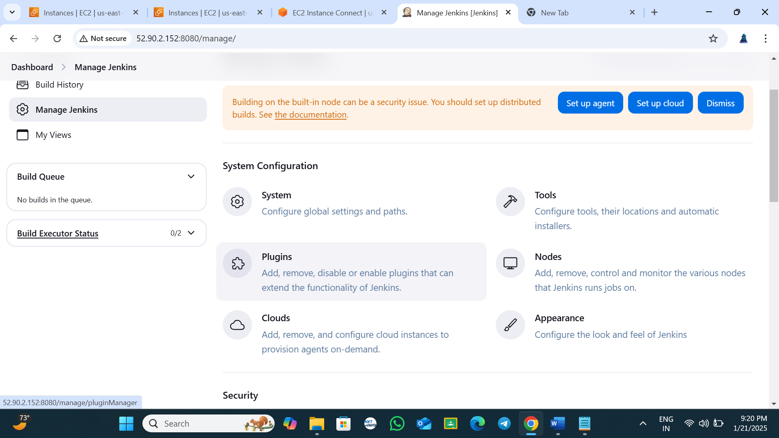

If you want install plugins

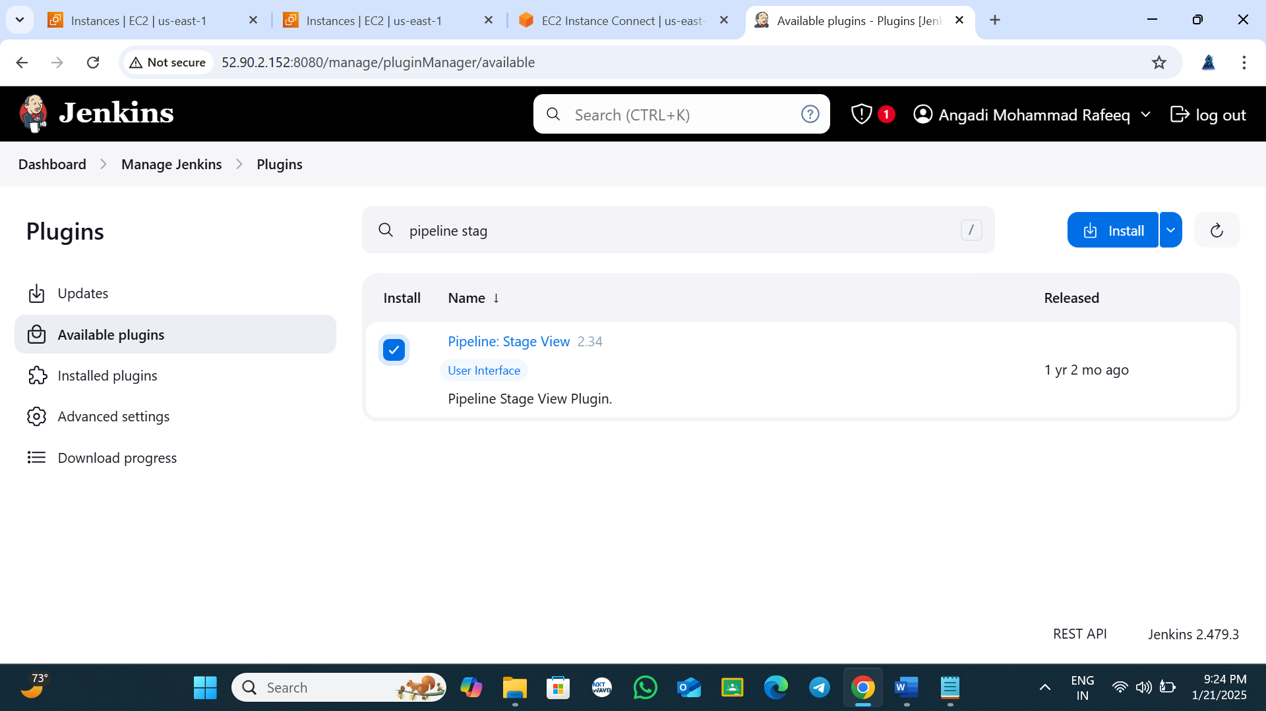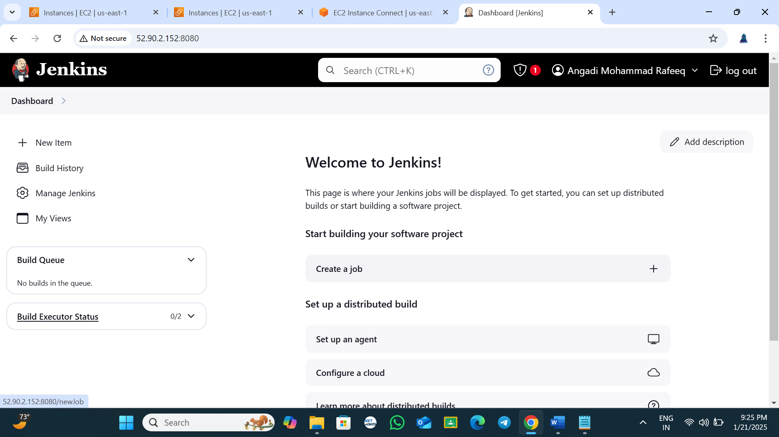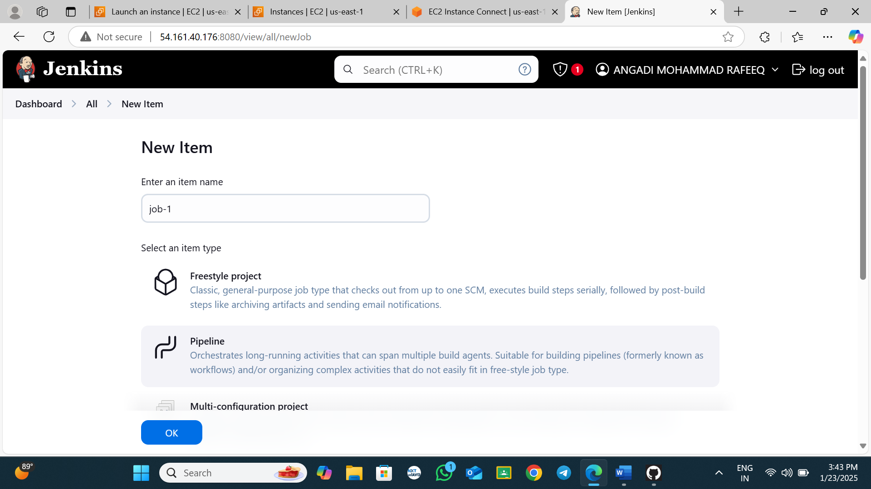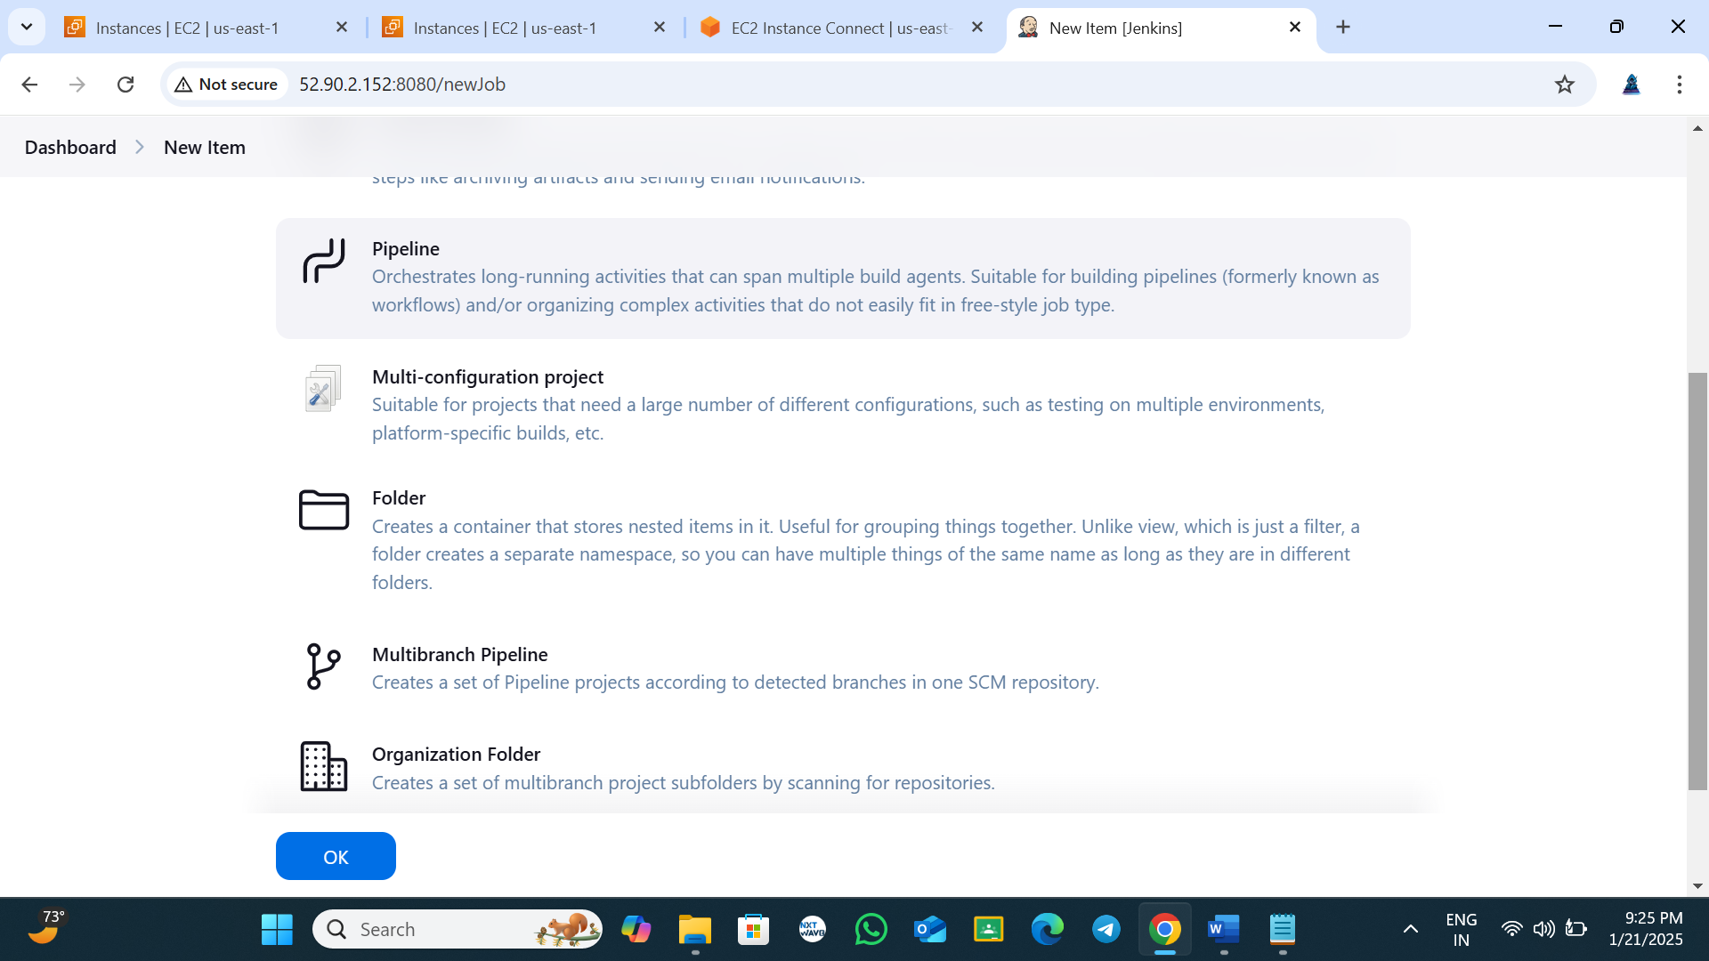

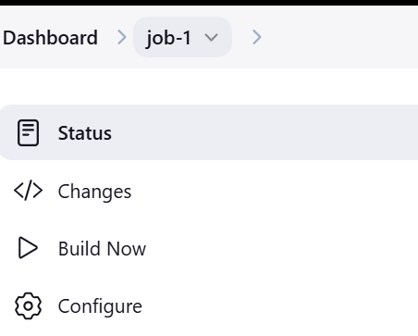

Go to github

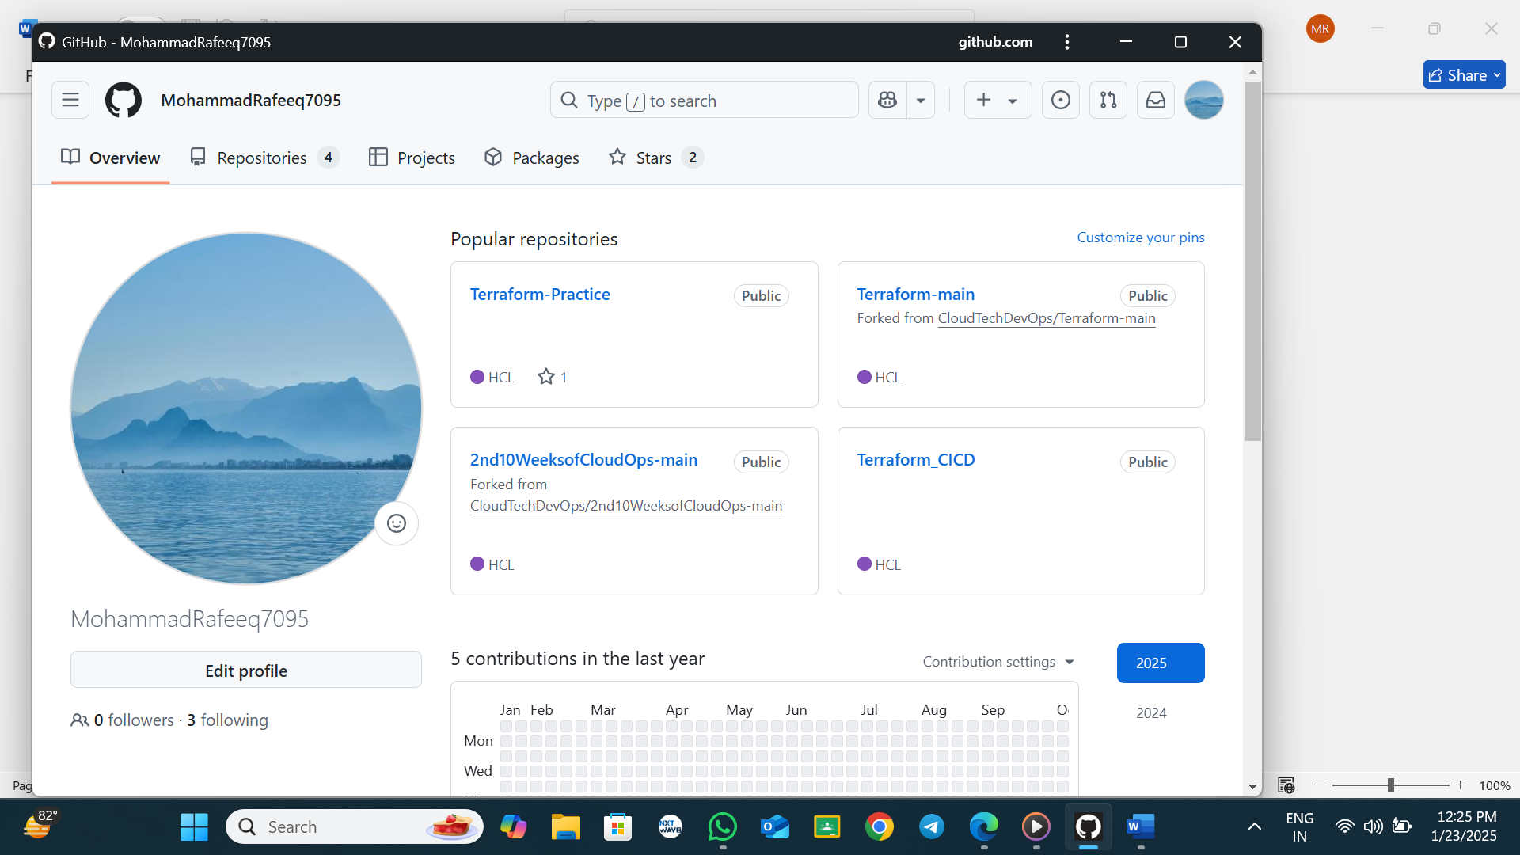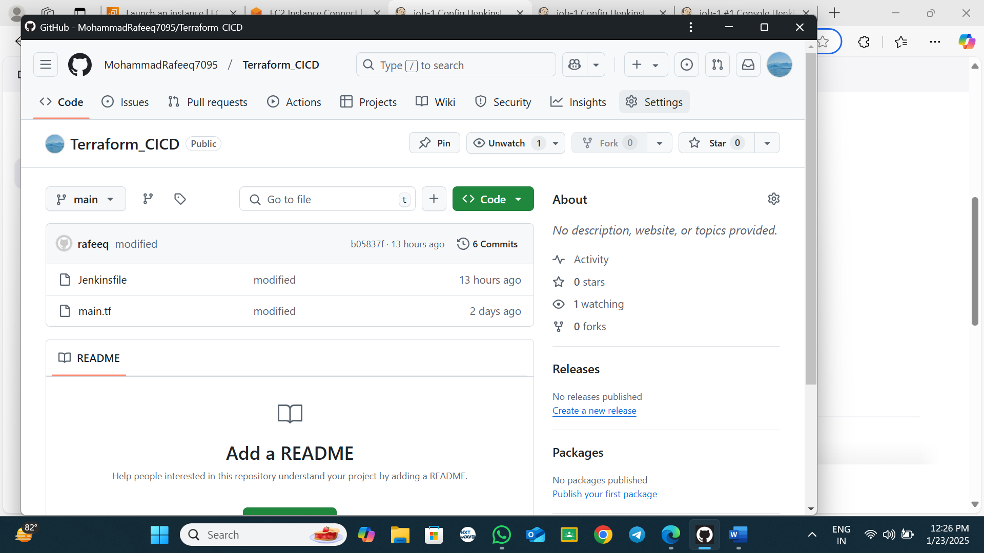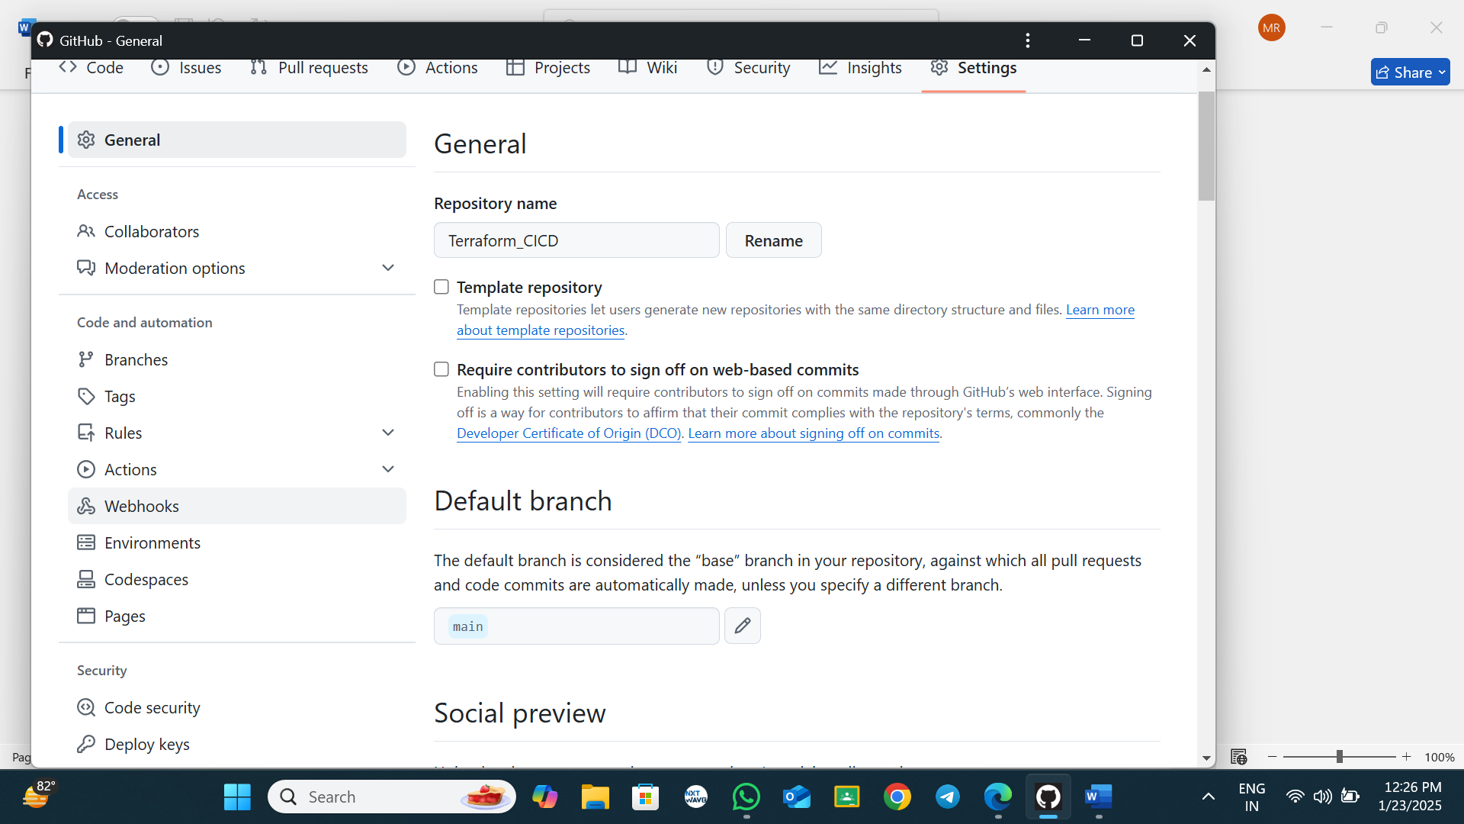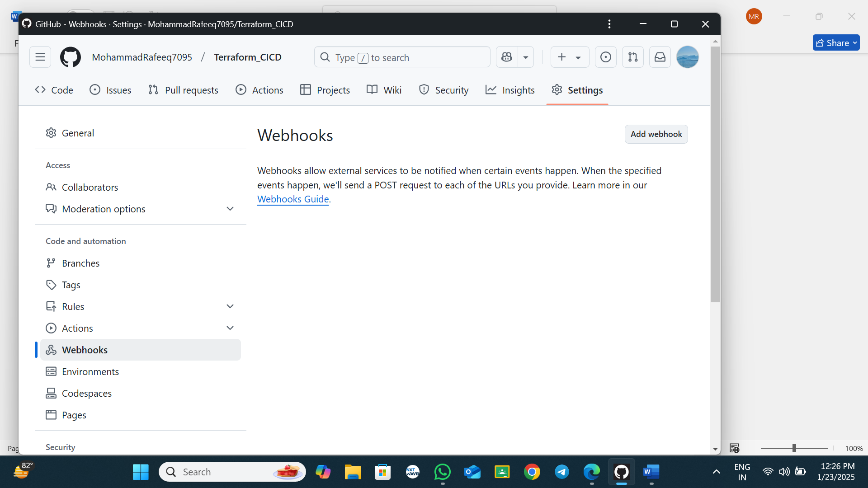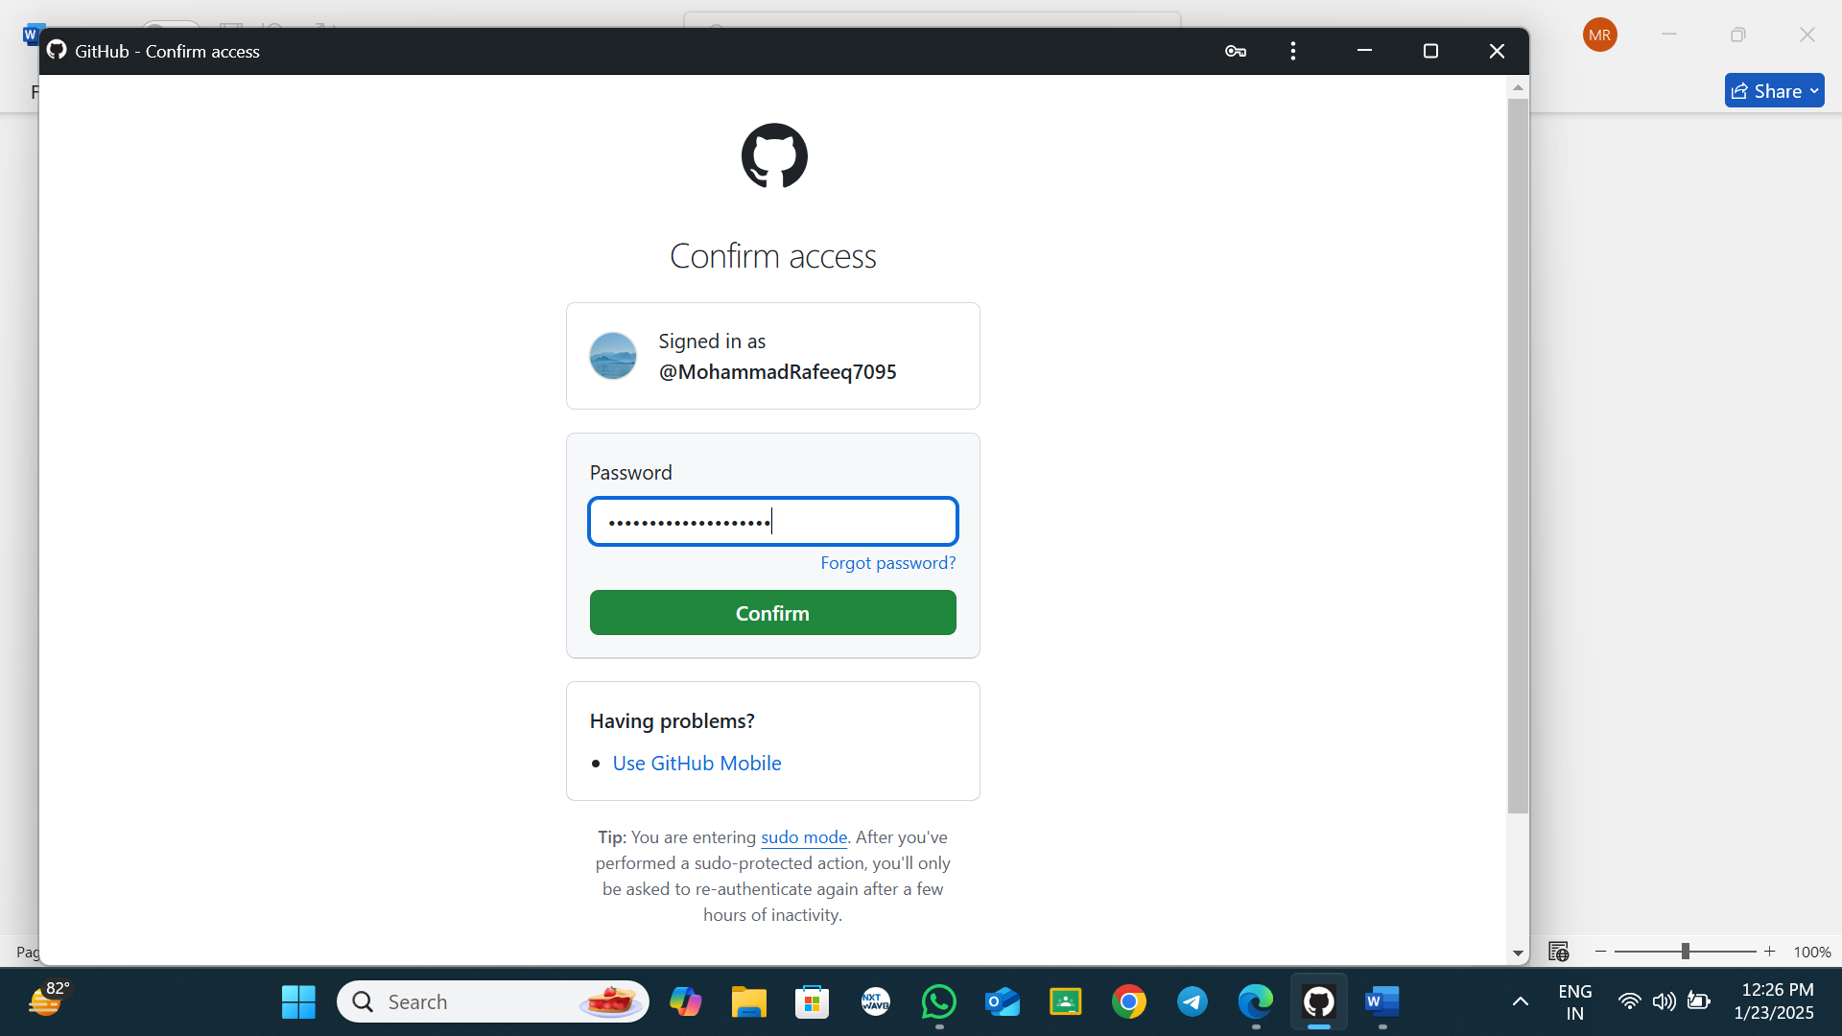

Copy the url past like given below

http://<your ip address>:8080/github-webhook/ #hear give your Jenkins server ip address

example: <http://52.23.203.45:8080/github-webhook/>

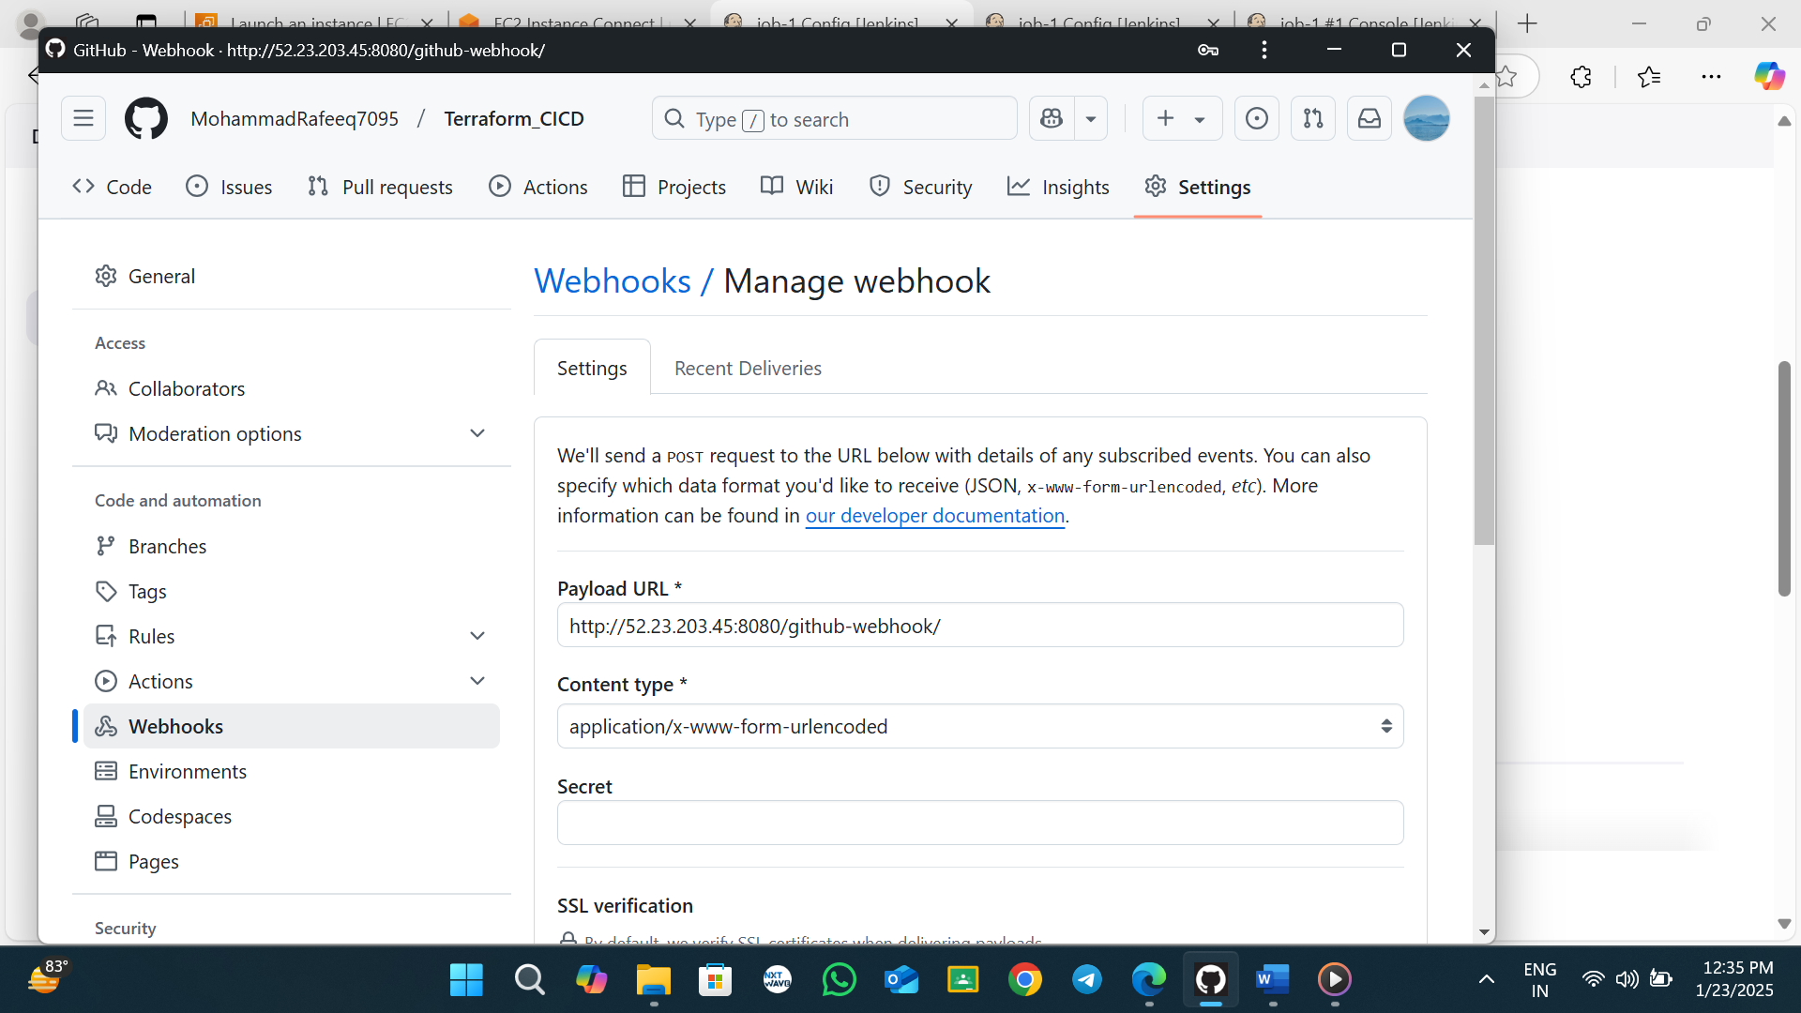

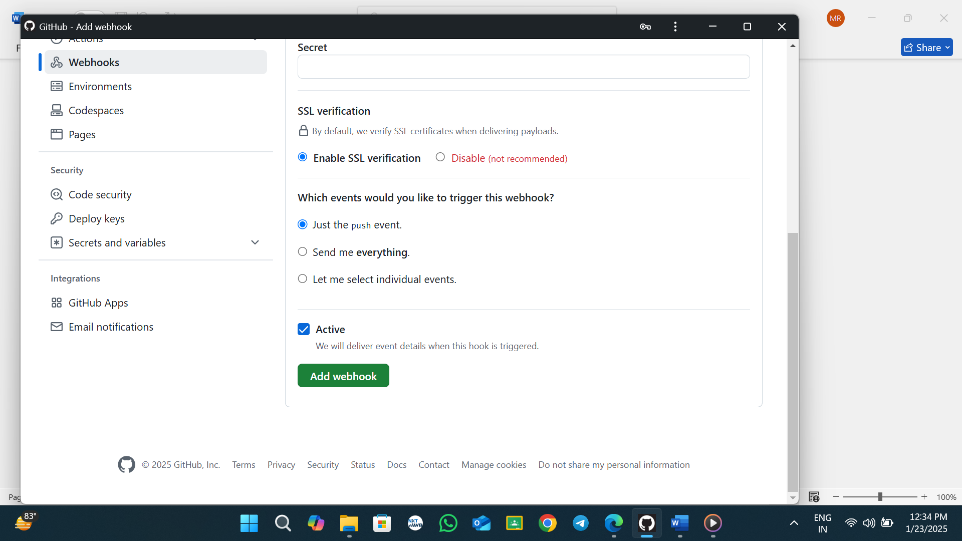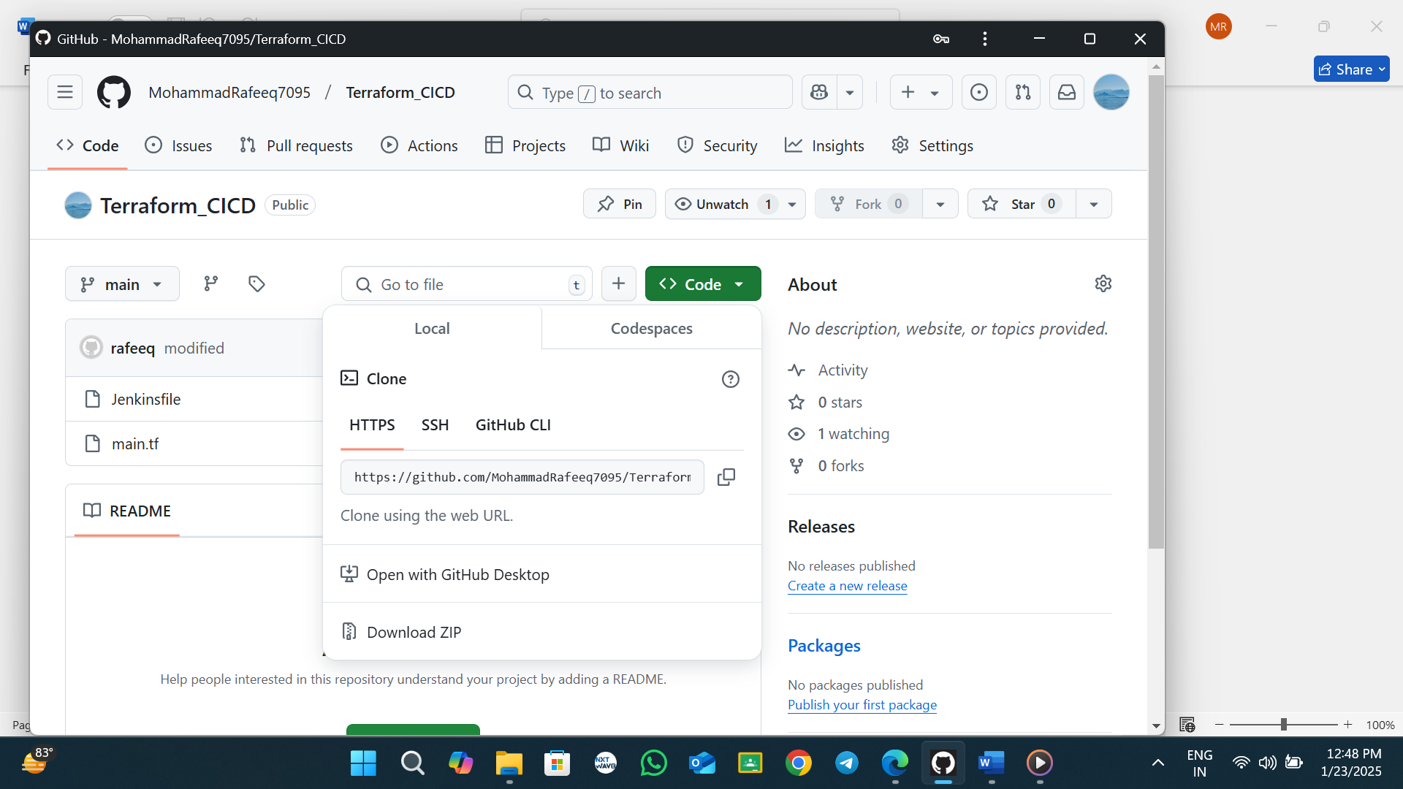

<https://github.com/MohammadRafeeq7095/Terraform_CICD.git>

use this url in your code and past the code in your job-1 pipeline

pipeline {

agent any

stages {

stage('git checkout') {

steps {

git branch: 'main', url: 'https://github.com/MohammadRafeeq7095/Terraform_CICD.git'

}

}

stage('terraform init') {

steps {

sh 'terraform init'

}

}

stage('terraform plan') {

steps {

sh 'terraform plan'

}

}

}

}

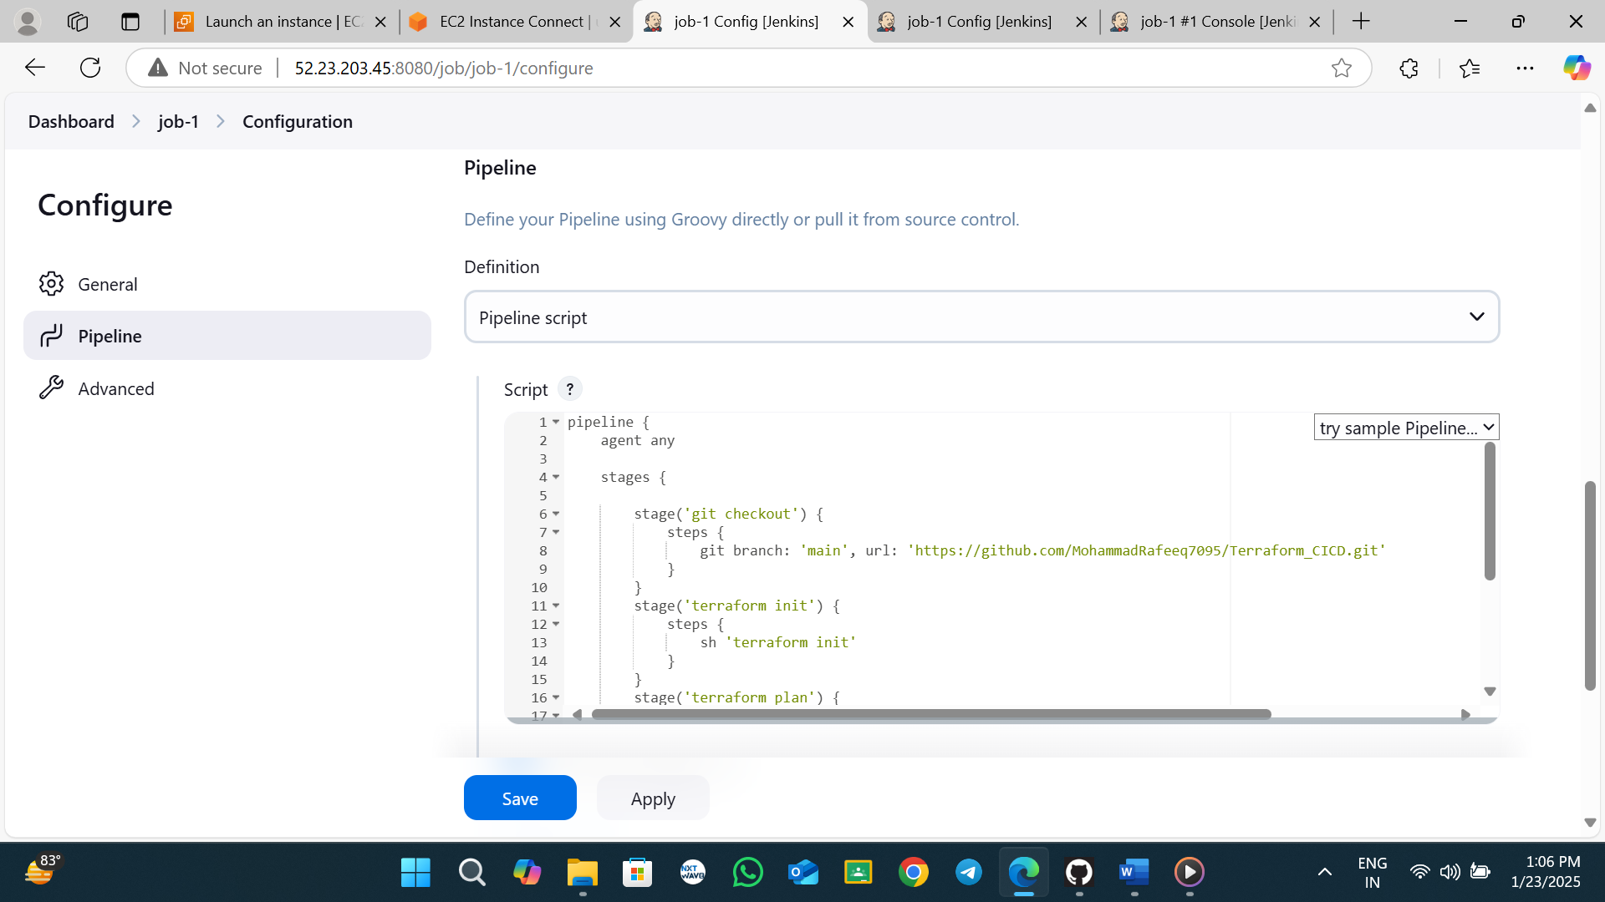 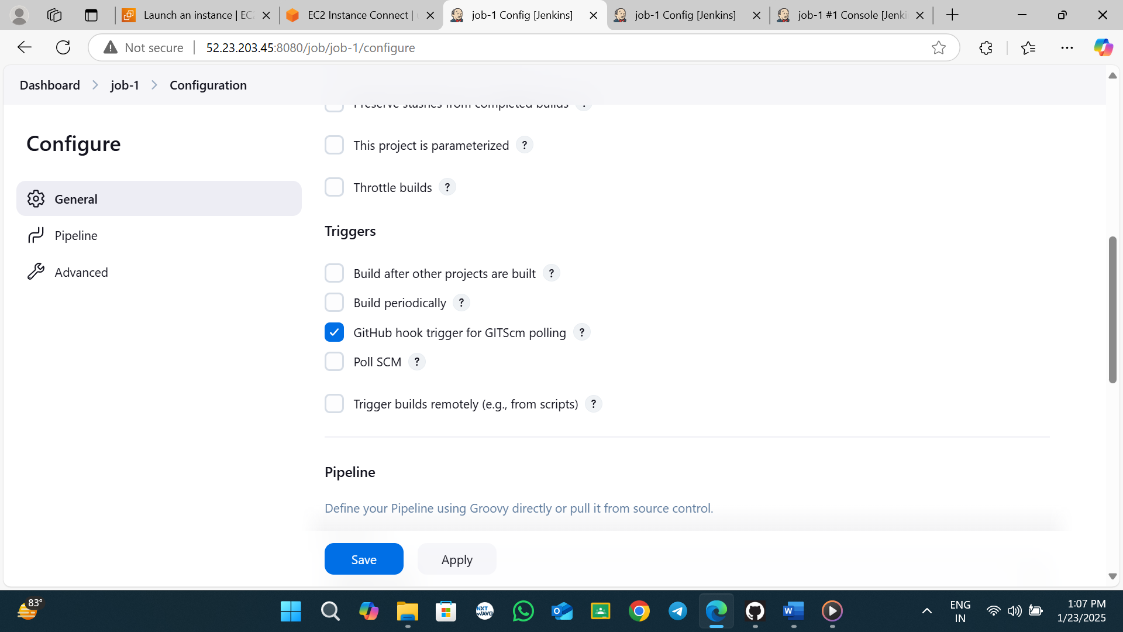

first run manually and next you change some changes in github your repo like given below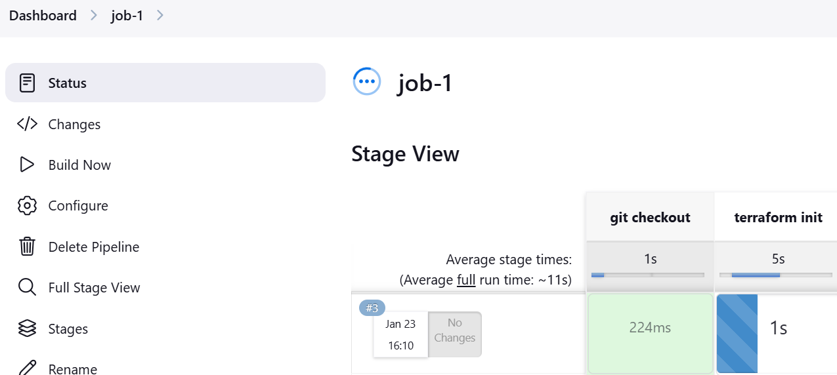

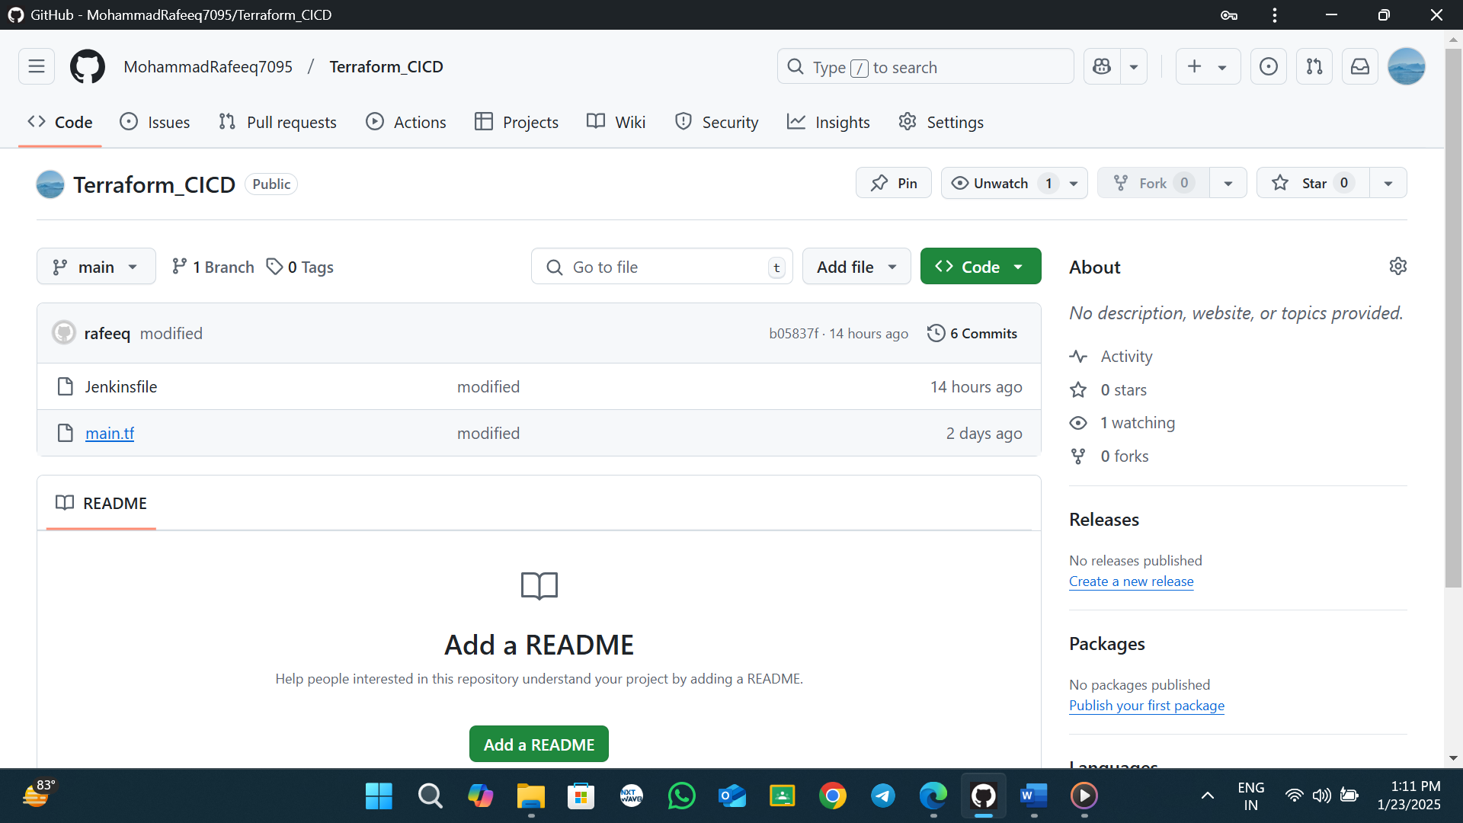 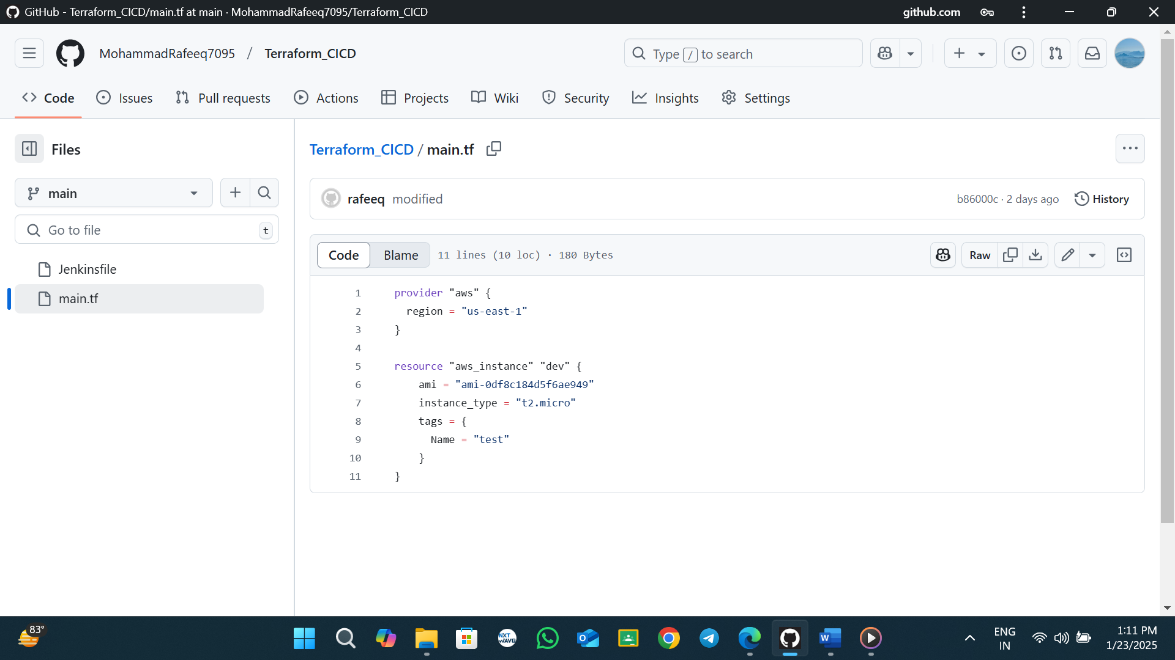 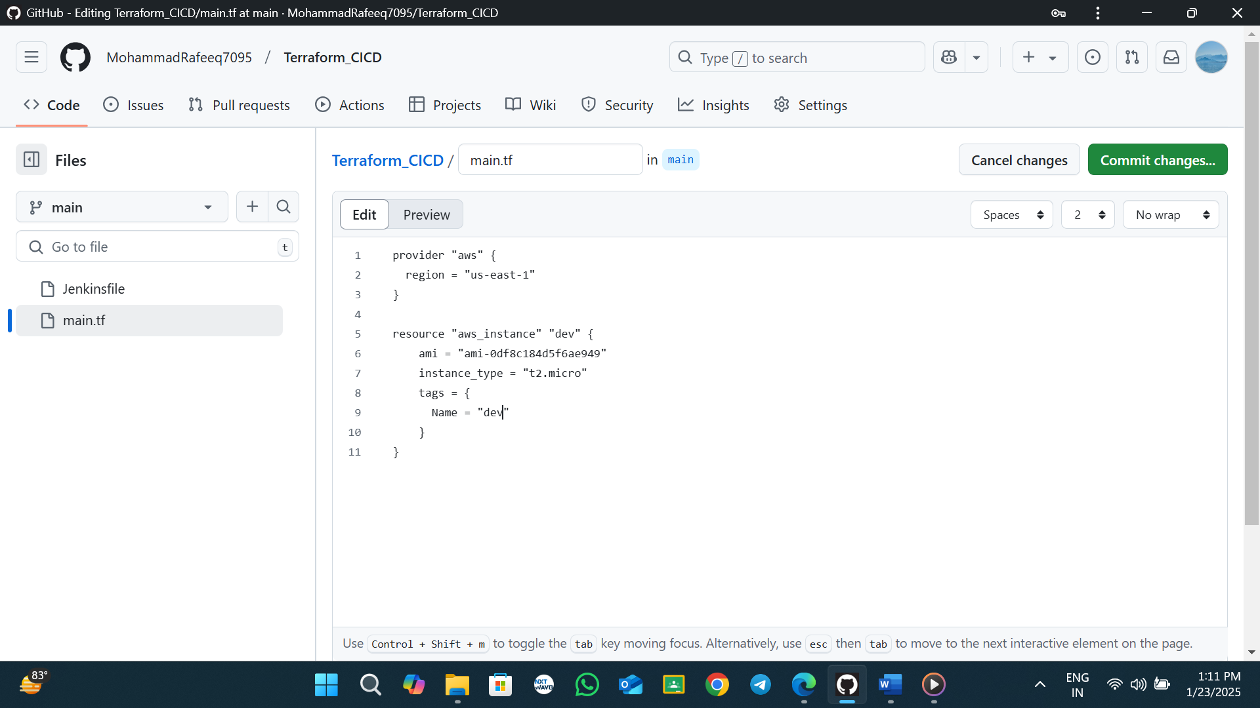 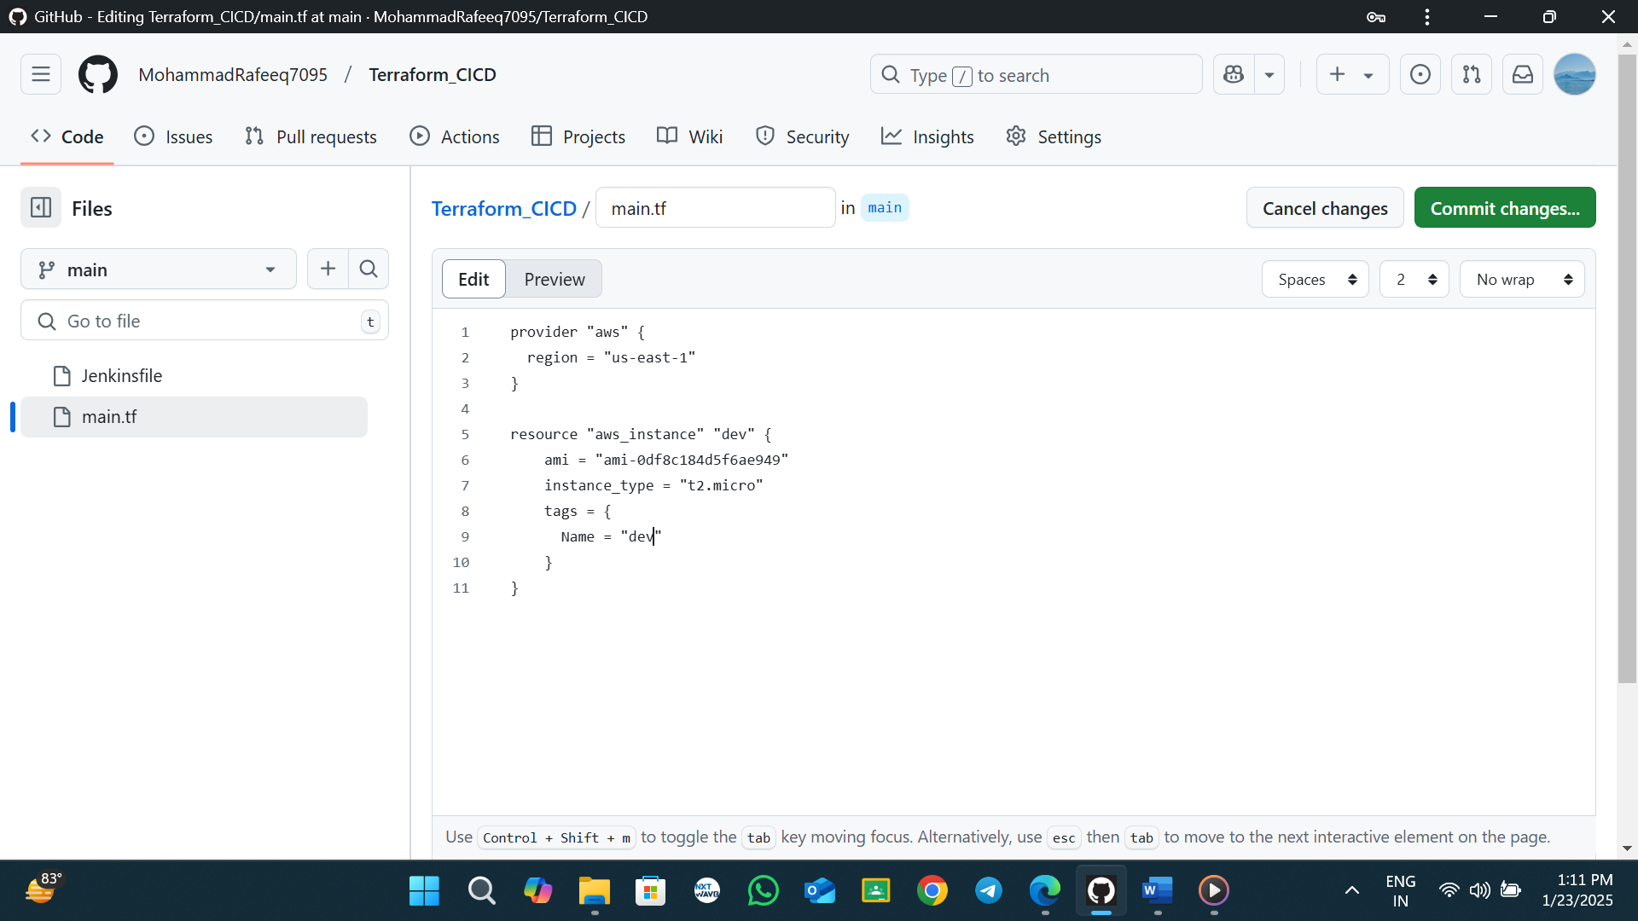 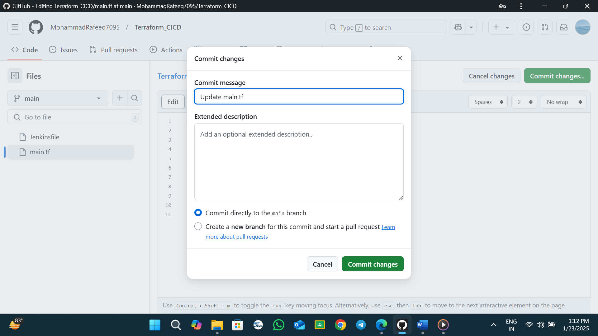 **see pipeline is trigged** 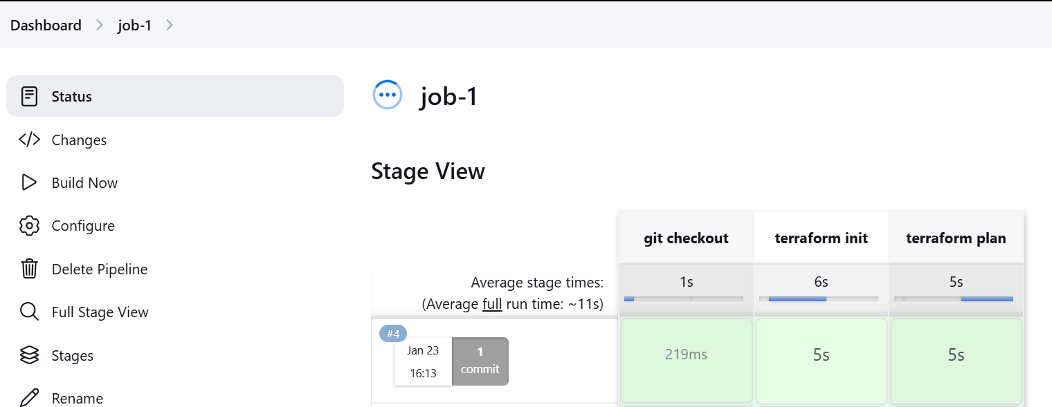

**Next users concept**

**Jenkins User Management**

* What is the Role Strategy in Jenkins?
  + How to install the Role-based strategy plugin in Jenkins?
  + And, how to enable the Role-based Strategy on Jenkins?
* How to Create a User in Jenkins?
  + How to manage user roles in Jenkins?
  + And, how to assign roles to a user in Jenkins?
* What is a Project-based Matrix Authorization strategy in Jenkins?
  + How to assign job-specific permissions in Jenkins?

**What is the Role Strategy in Jenkins?**

The role-based strategy helps in defining what different access types can be assigned to individual users. As we discussed, not all the users can be provided administrative privileges, So [**Jenkins**](https://www.toolsqa.com/jenkins/what-is-jenkins/) provides the capability to provide different roles to individual users. This capability is achieved using the [**"Role-based strategy plugin".**](https://plugins.jenkins.io/role-strategy/)

The Role-based strategy plugin is a special kind of plugin in Jenkins that is based on the role-based mechanism and allows us to manage users' permission. A few of the major features provided by this plugin are:

* Global roles such as admin, anonymous, job creator that allows setting permission like job, view, agent, run and SCM, etc.
* Project roles that allow us to access particular projects with jobs and run permissions.
* Agent roles that are used to set node related permissions.
* Roles can be assigned to users and user groups with the help of this plugin.

So, let's understand how we can install this plugin in Jenkins and start using its capabilities for managing the user roles?

Step-1: we need to install plugins in Jenkins dashboard let go to dashboard and click manage Jenkins

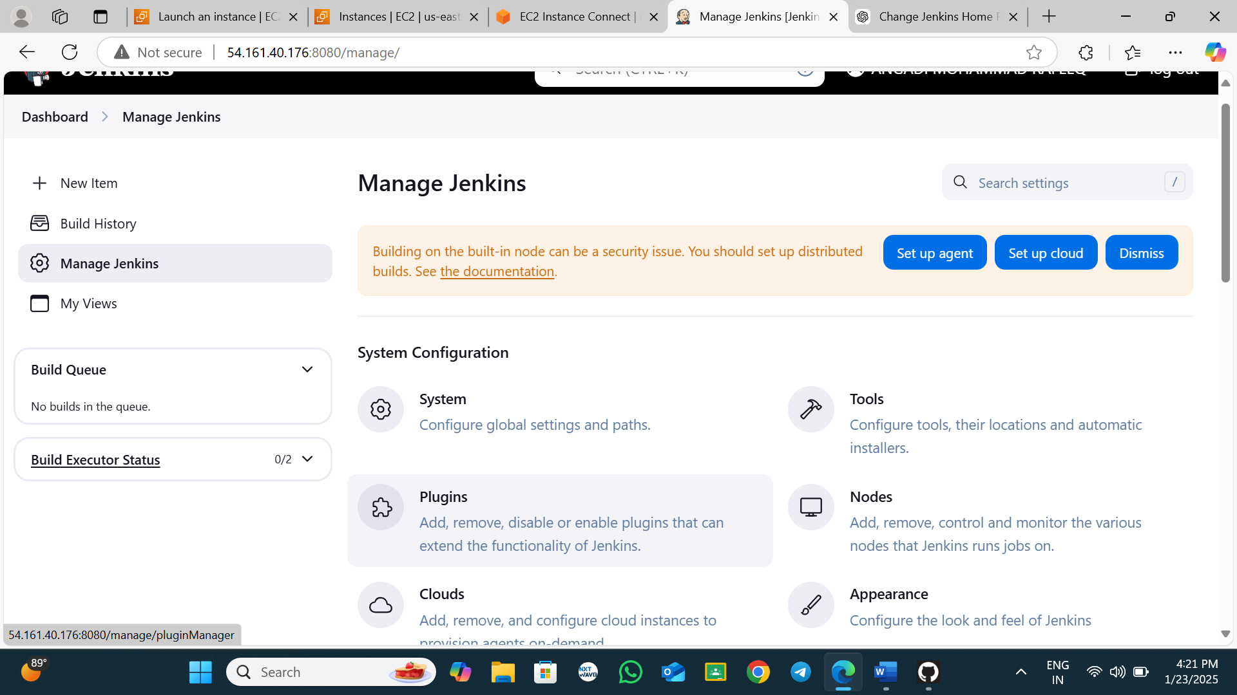

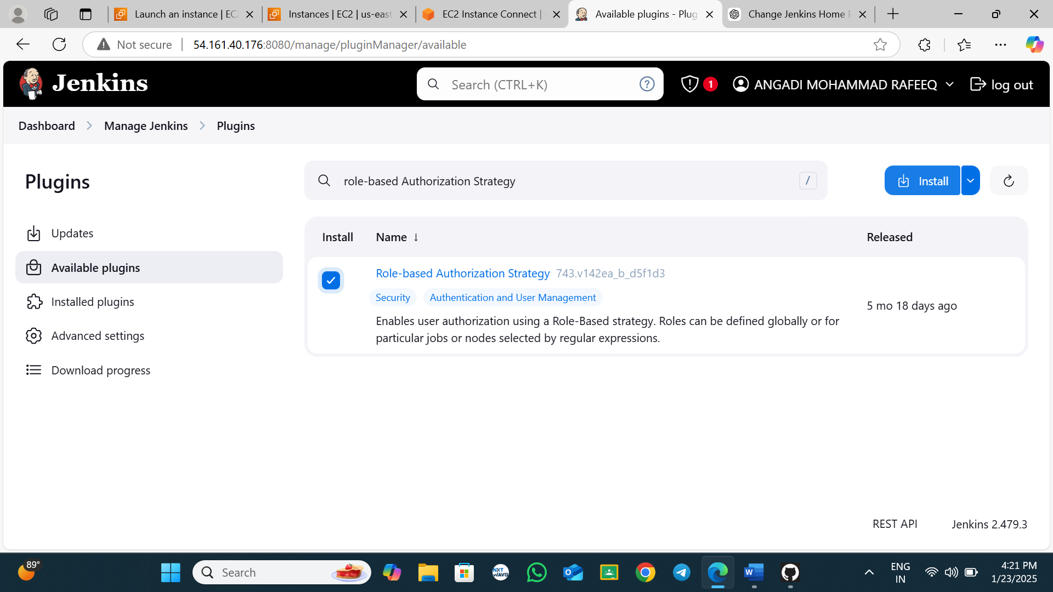 Go to dashboard and click manage Jenkins  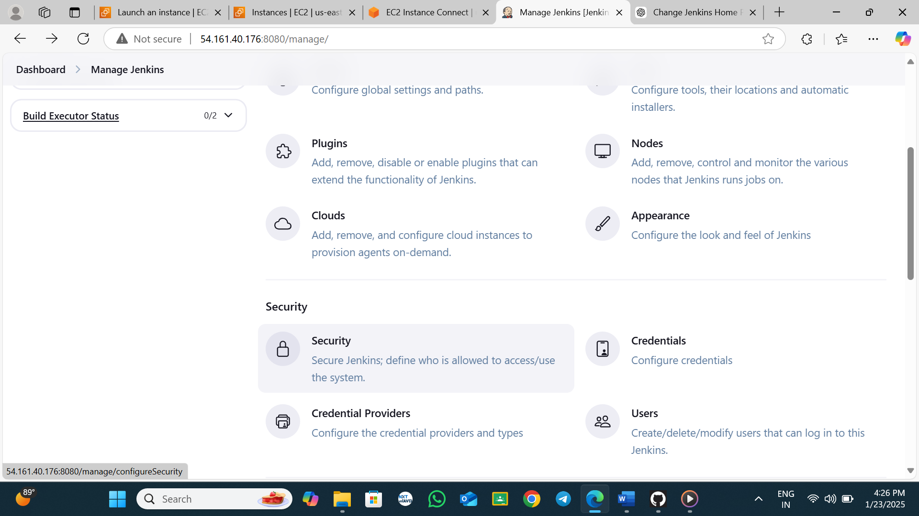 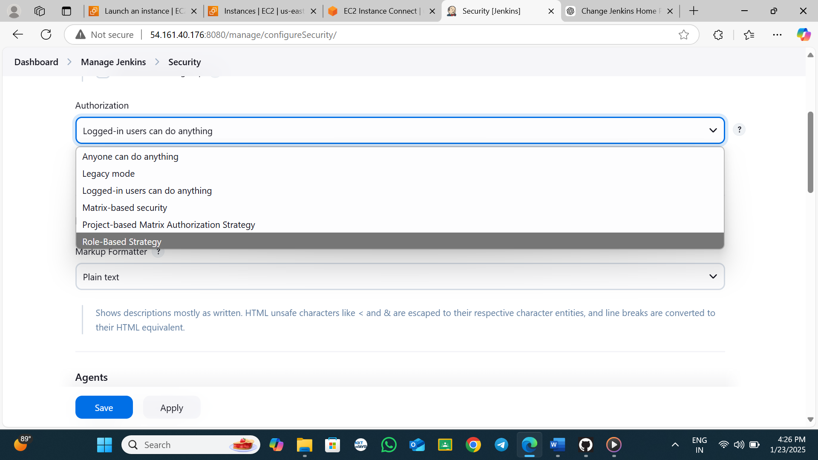 step-2 change to Role-Based Strategy and save 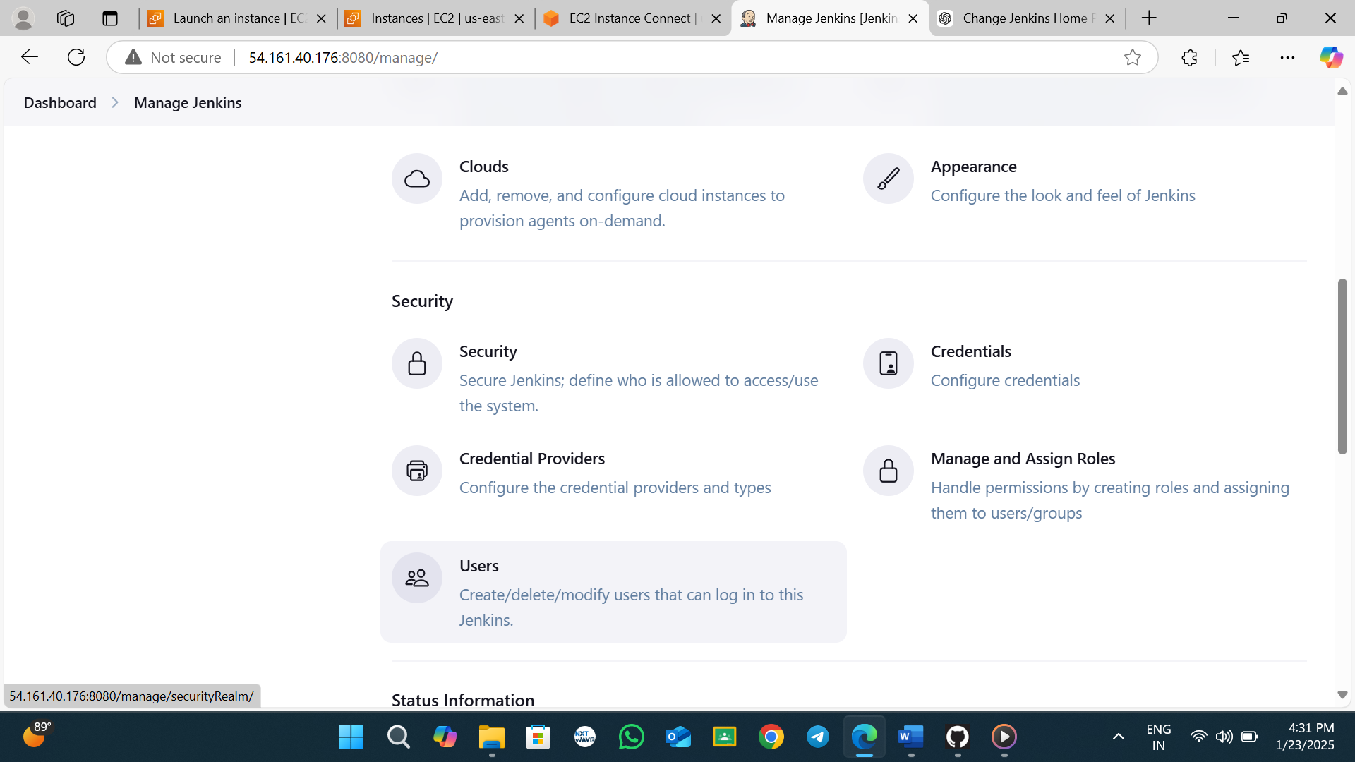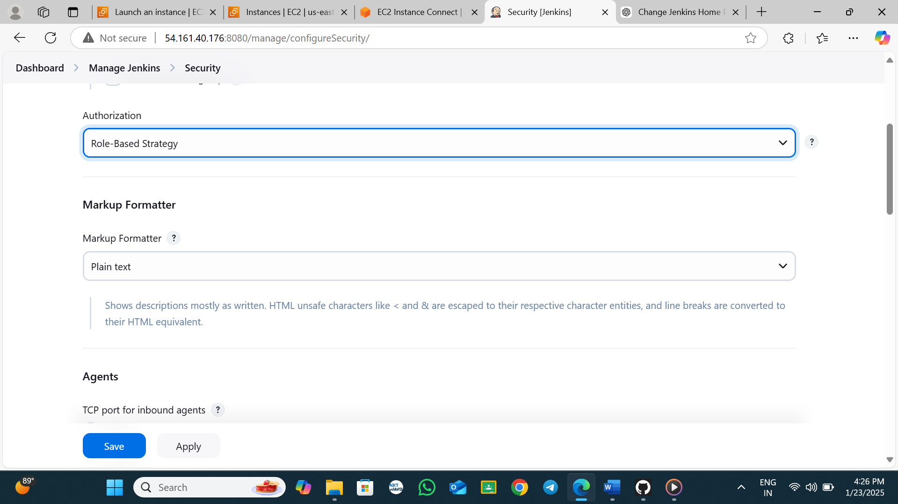

**Step-3 create user**  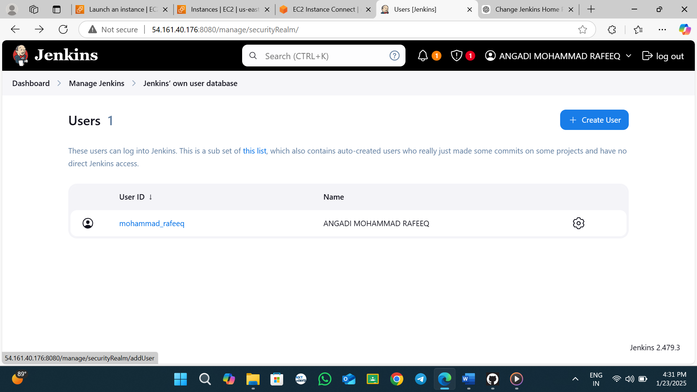

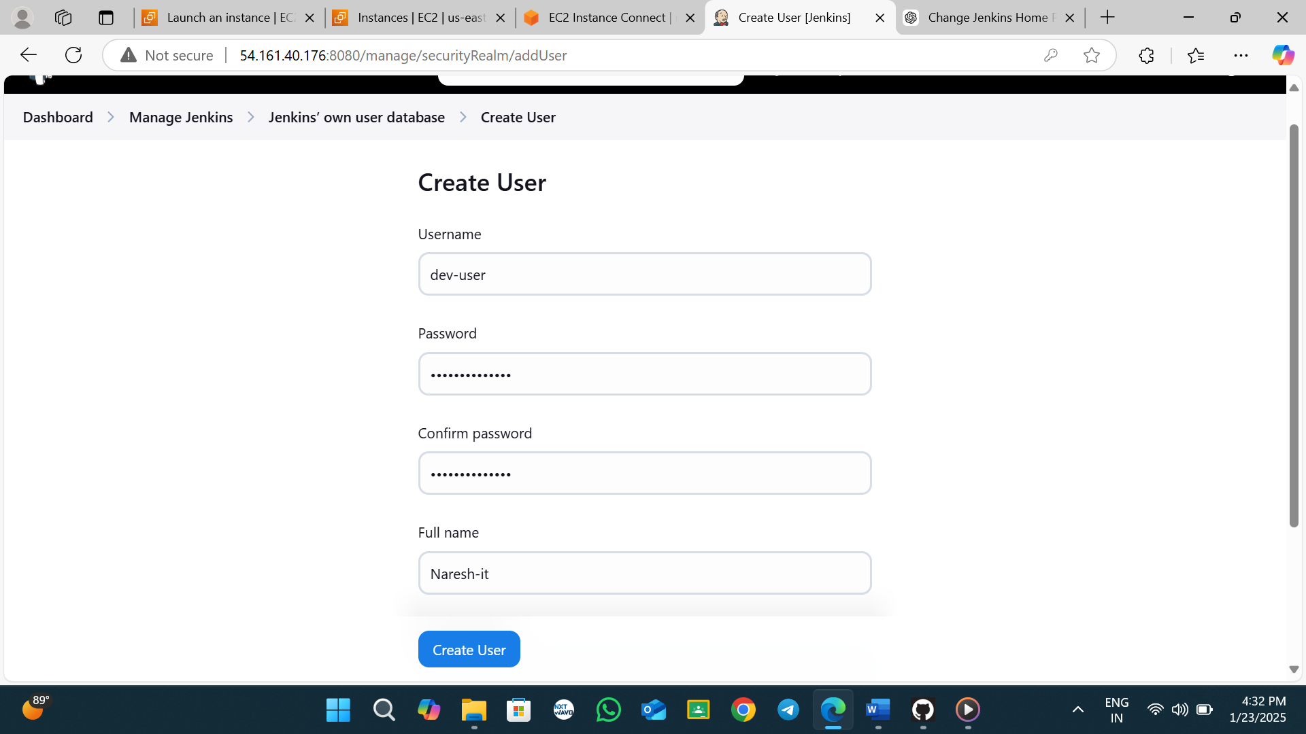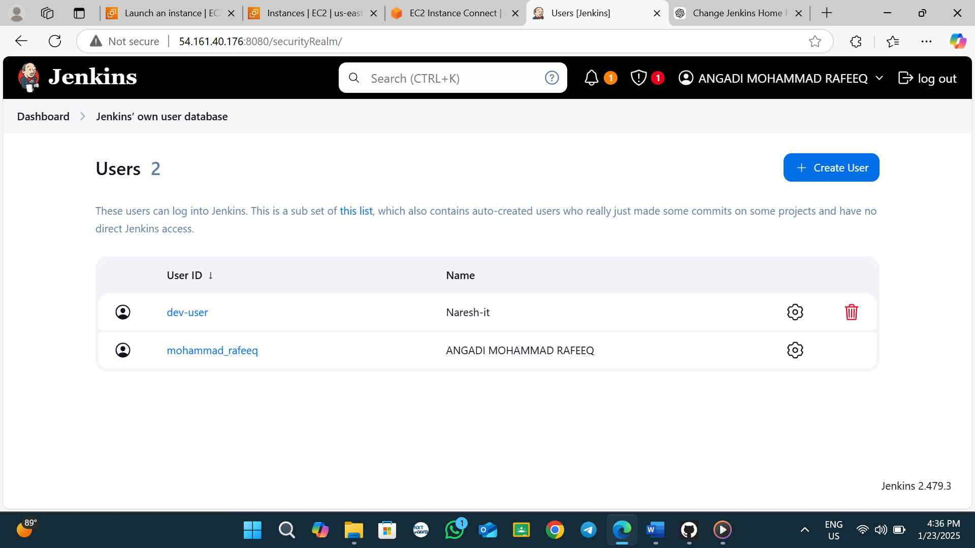copy your url and past it into another browser <http://54.161.40.176:8080/> and give created user details 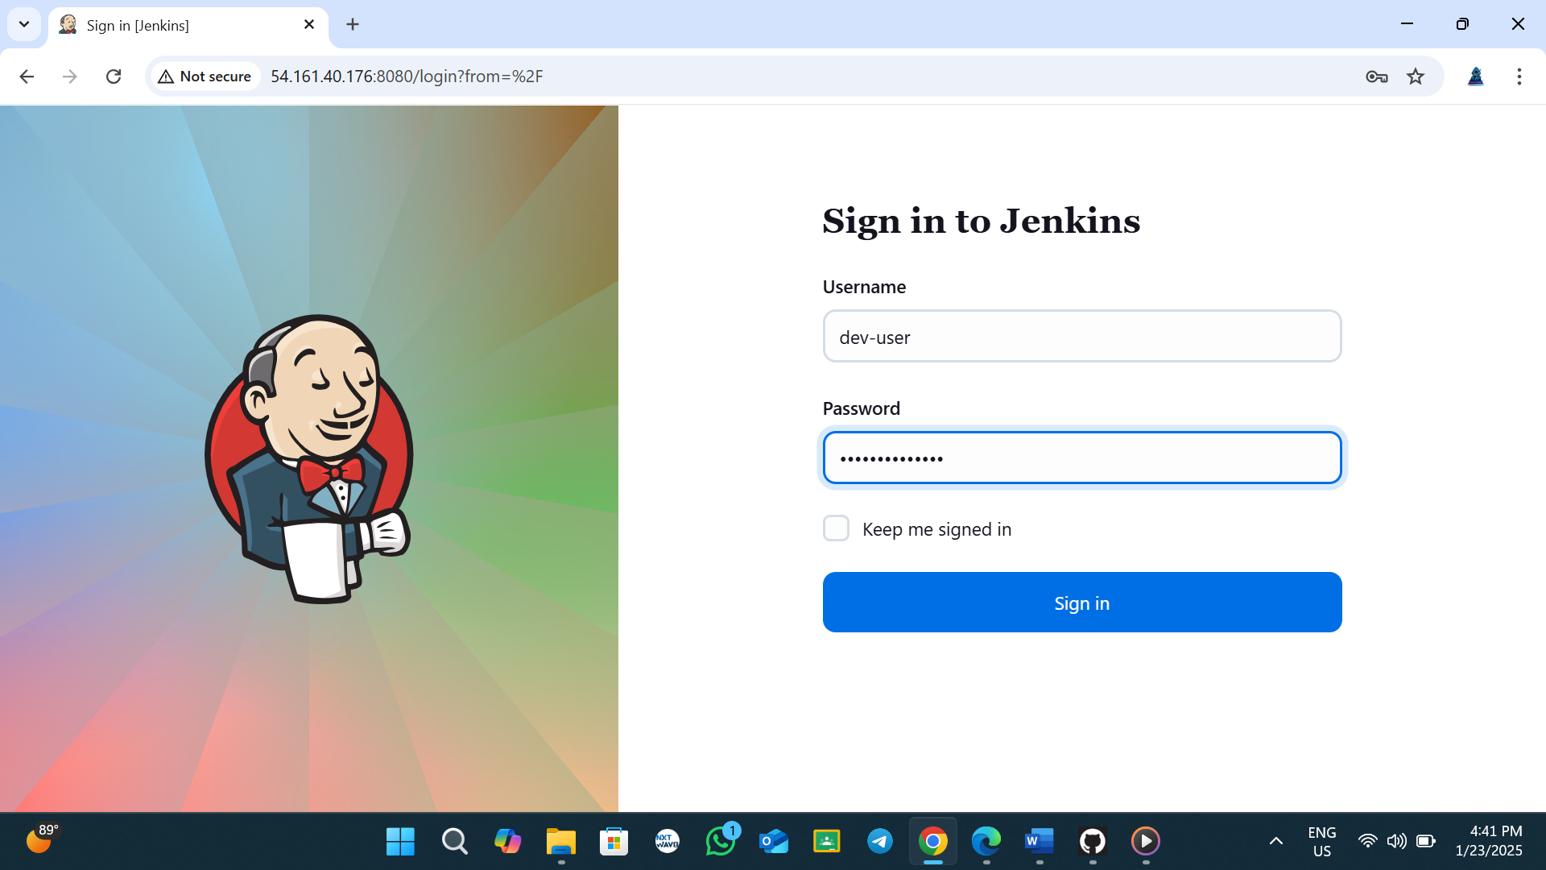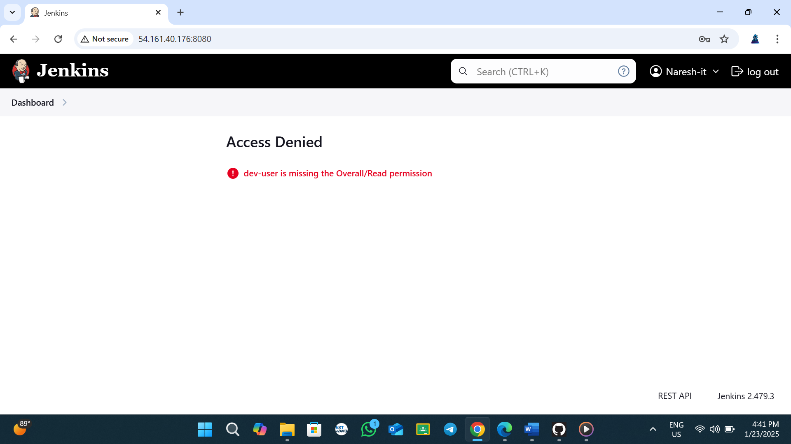see to access why we can’t given permissions

**Step-4 give permissions to your user go to your main account and give like given below**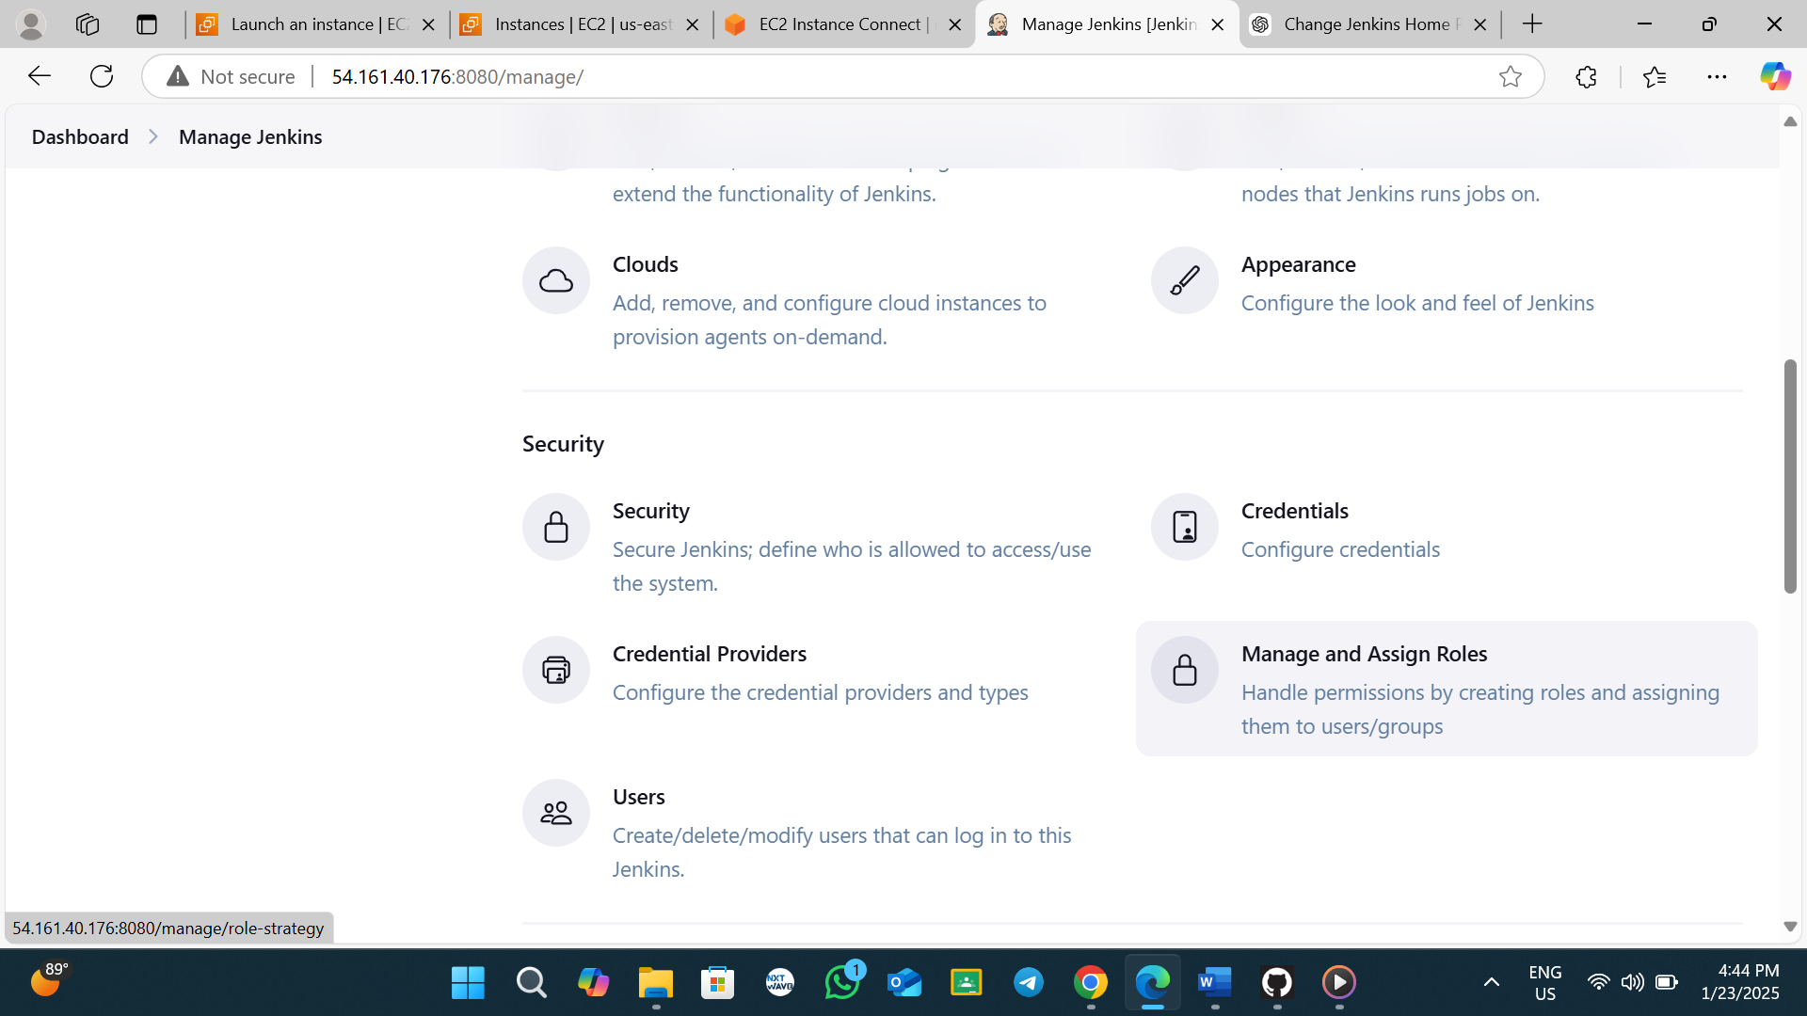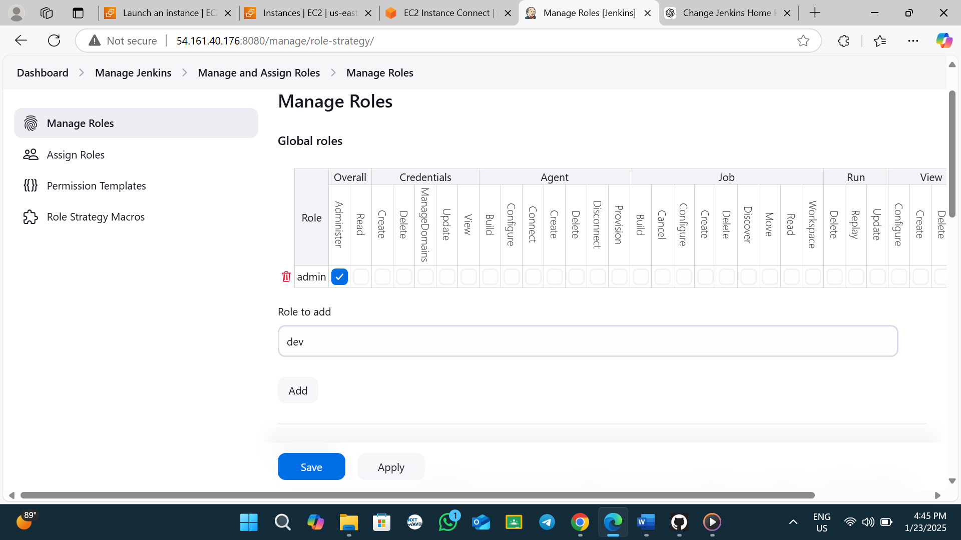 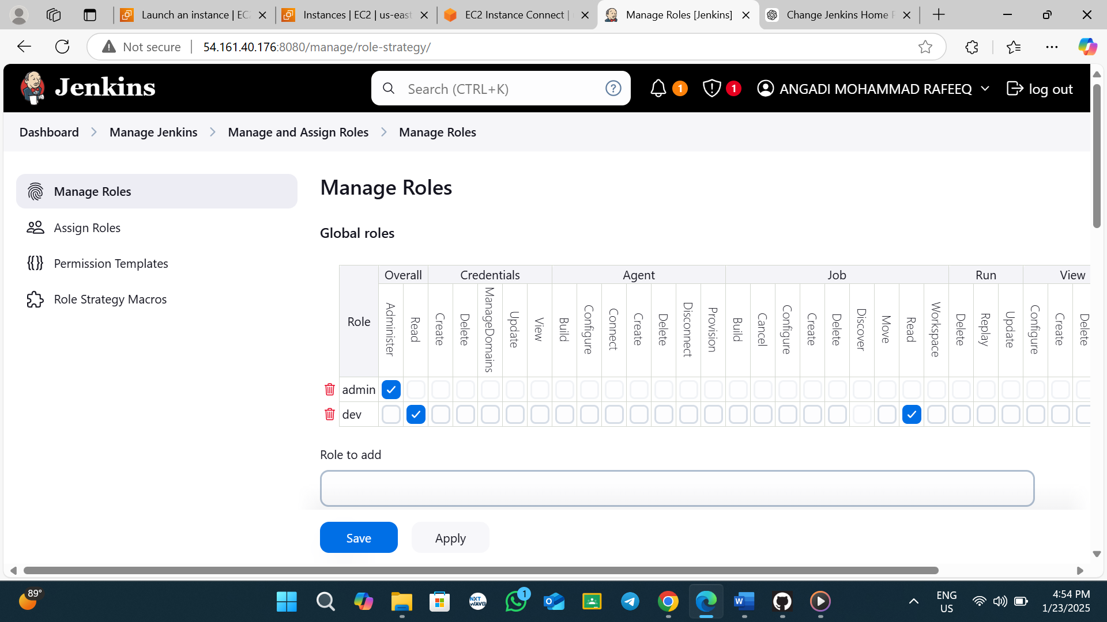

2

1

**Create Role**

**Give what your user wants I am given read only access and save Assaining role to my user**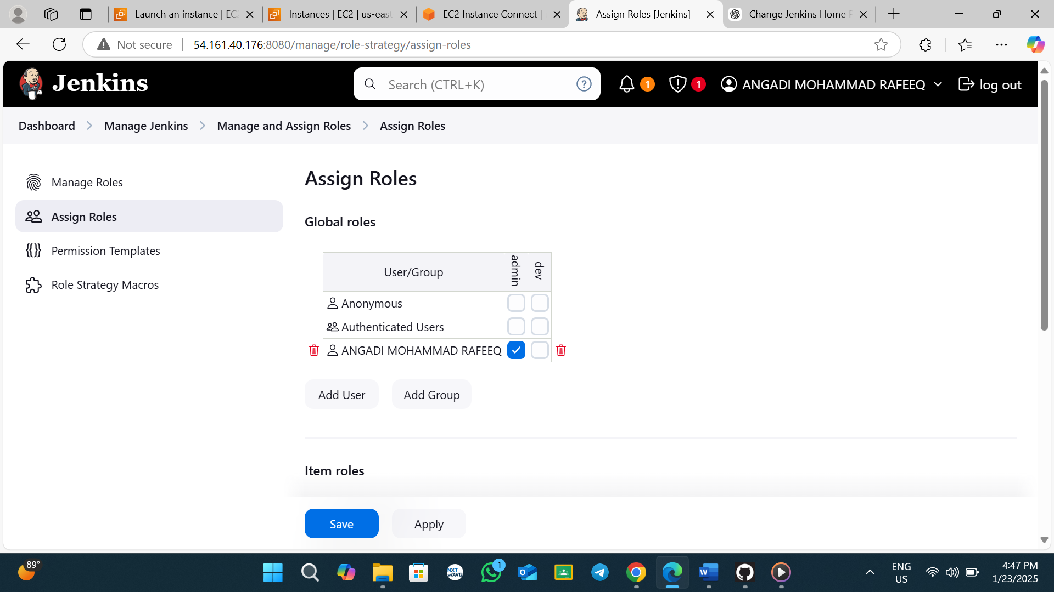

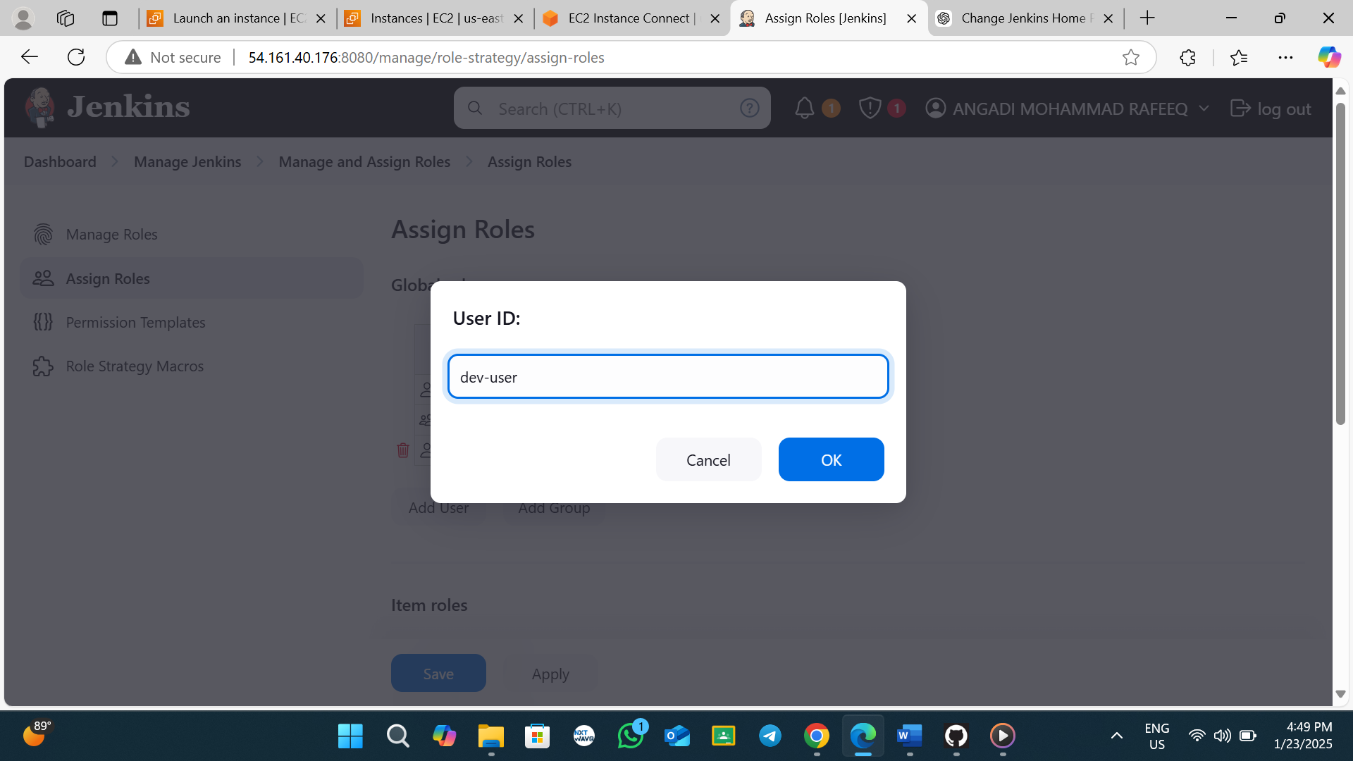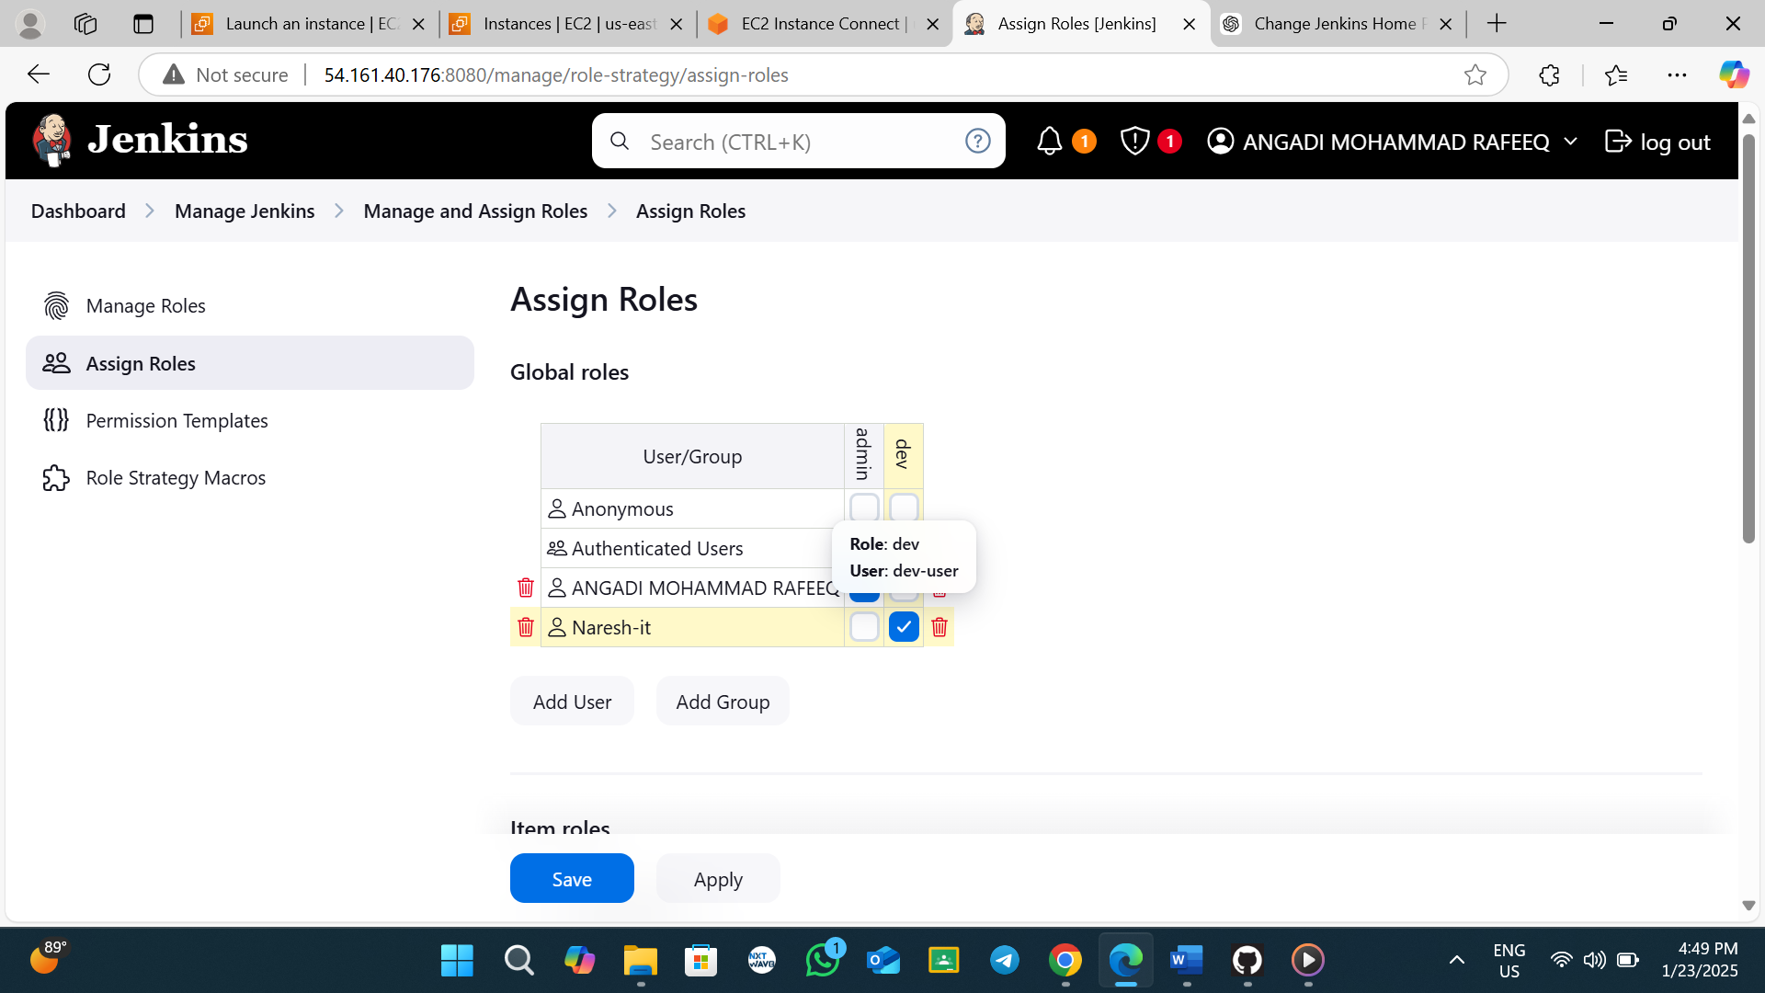

**Go to user browser and reload** 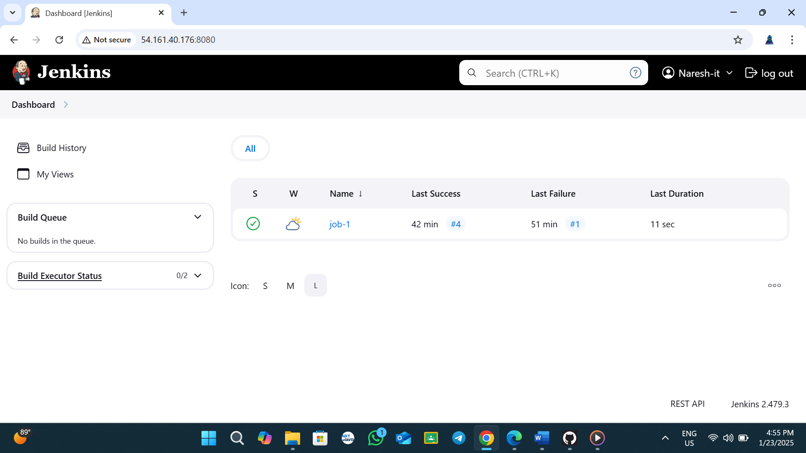see access read only

Toplic -3

Create one more job job-2 and add trigger name is 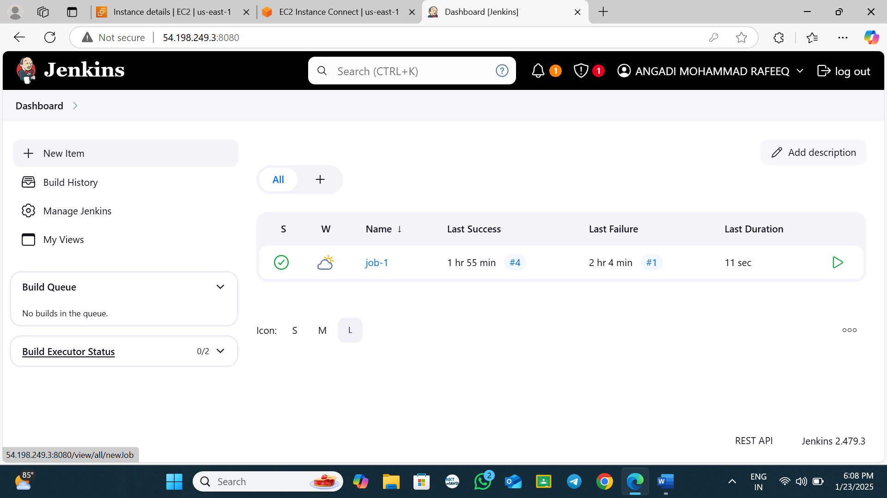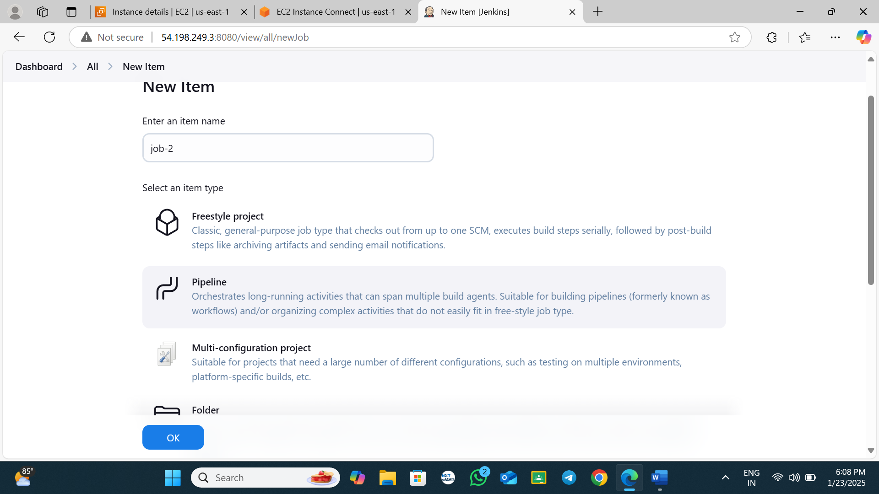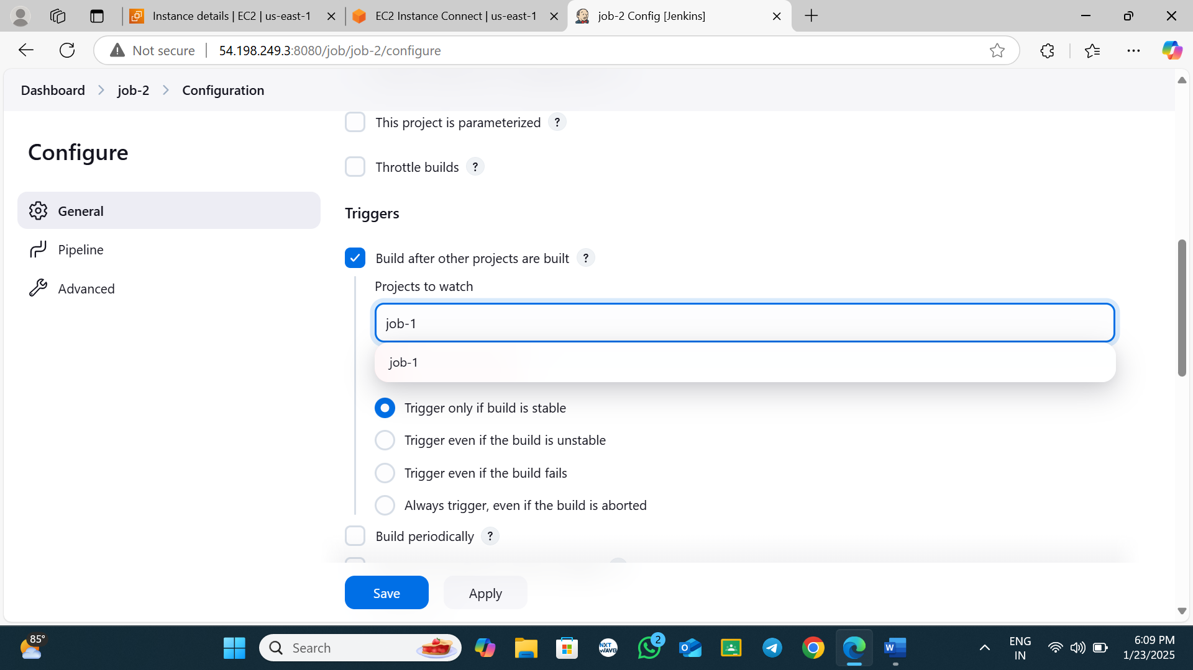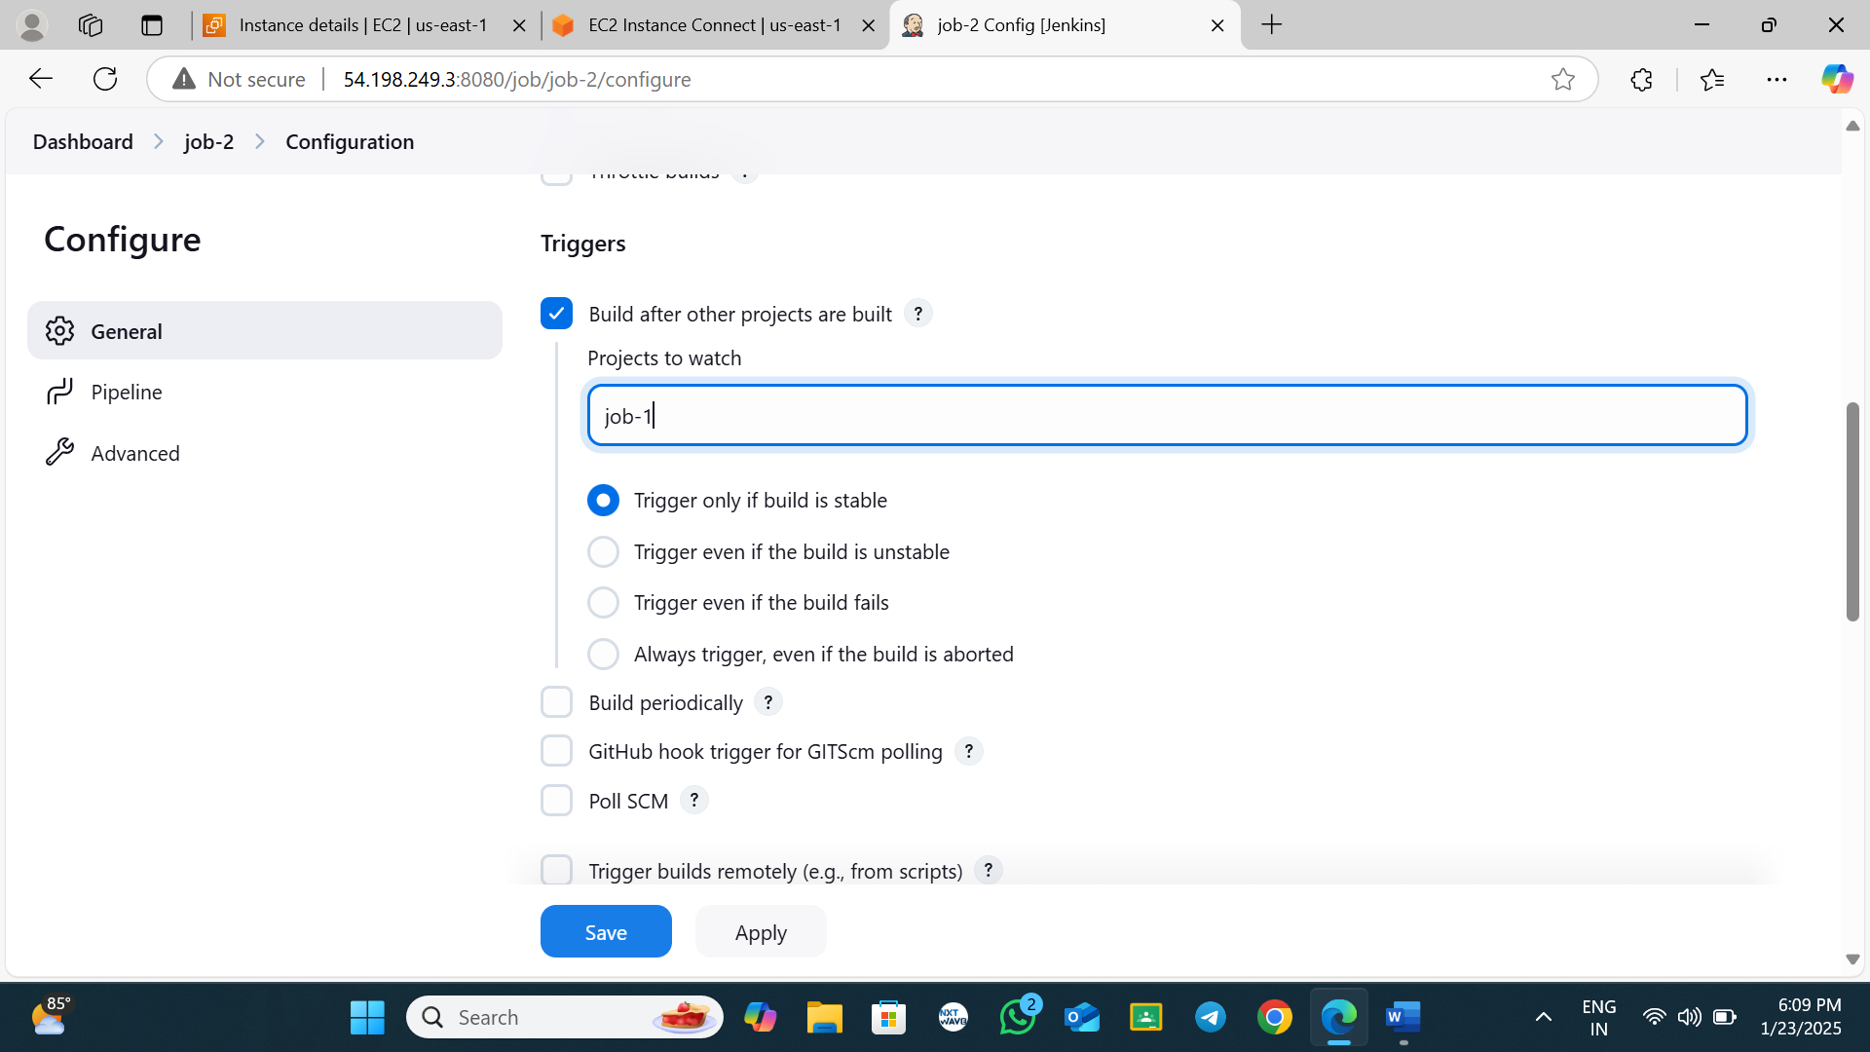go to job-1 and run the script

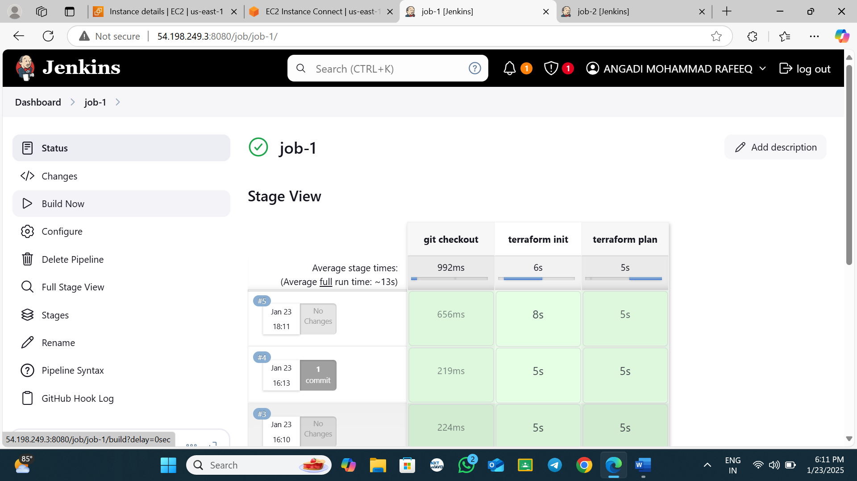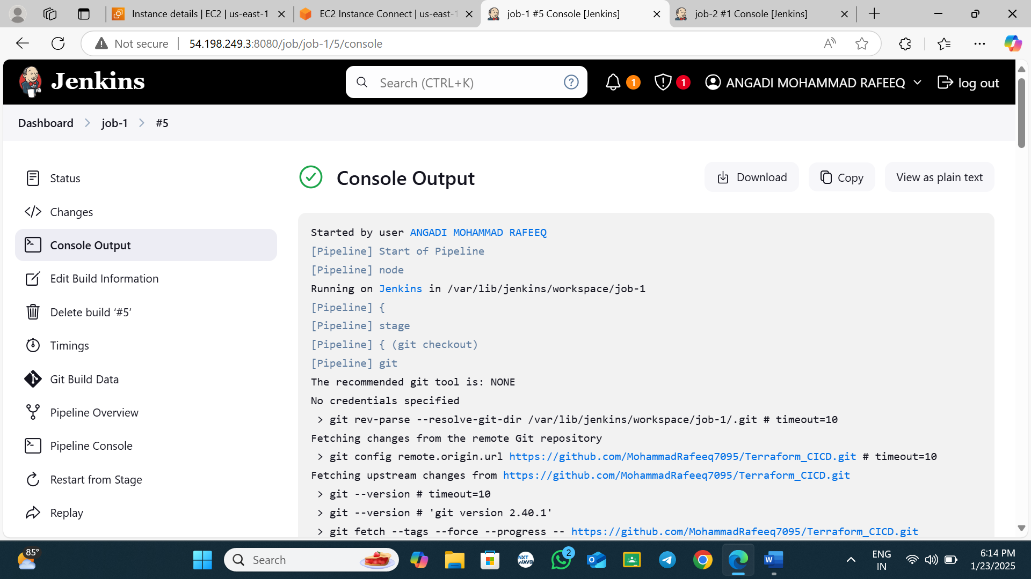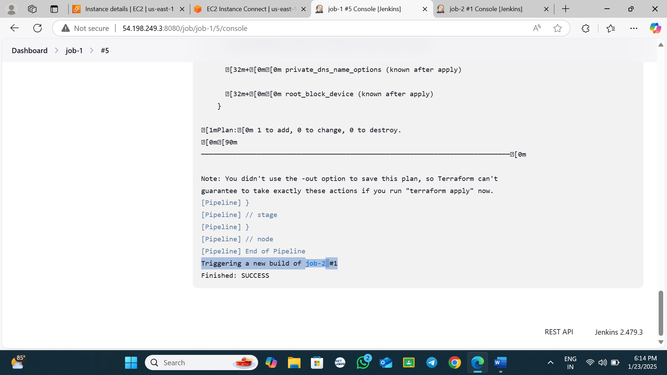**see job-2 also triggred after job-1 is over**

**------------------------------------------ --------------------------------------------**

**------------------------------------------------ --------------------------------------------**